

**REAL-TIME CROWD DETECTION ANALYTICS IN TRADING OUTLETS**

by

PULKIT KHANDELWAL(2048017)

ASHRITHA K (2048029)

Under the guidance of Dr. SARAVANAN K S

A Project report submitted in partial fulfillment of the requirements for the award of degree of Master of Science (Data Science) of CHRIST (Deemed to be University)



CERTIFICATE

*This is to certify that the report titled* ***Real-Time Crowd detection analytics in Trading Outlets*** *is a bona fide record of work done by* ***Pulkit Khandelwal ( 2048017) and Ashritha k - 2048029*** *of CHRIST (Deemed to be University), Bengaluru, in partial fulfillment of the requirements of III Semester M.Sc (Data Science) during the year 2020.*

**Head of the Department Project Guide**

Valued-by:

|  |  |  |
| --- | --- | --- |
|  | Name | : |
| 1. | Register Number | : |
|  | Examination Centre | : CHRIST (Deemed to be  University) |
| 2. | Date of Exam | : |

# ACKNOWLEDGEMENTS

The success and final outcome of this project required a lot of guidance and assistance from many people and we are extremely fortunate to have got this all along the completion of our project work. Whatever we have done is only due to such guidance and assistance and we would not forget to thank them.

First and foremost we would like to thank god almighty for giving us good health and for helping us complete this project in time.

We respect and thank our department head Prof. Joy Paulose and our coordinator Dr.Senthilnathan T for giving us an opportunity to develop this project work. We owe our profound gratitude to our project guide Dr. Sarvanan K S, who took keen interest on our project work and guided us all along, till the completion of our project work by providing all the necessary information for developing a good project.

We would not forget to remember Dr. Saleema J and Dr. Cecil of the computer department for the suggestion and guidance during the project presentation.

We heartily thank our Alumni evaluator, -------------------for his guidance and suggestions for this project work during the alumni project presentation.

We are thankful to and fortunate enough to get constant encouragement, support and motivation from our class teacher Dr.Sreeja which helped us in successfully completing our project work.

Last but not the least, we would also like to thank our family and friends for their constant support and guidance for the smooth development of this project.

Pulkit Khandelwal

Ashritha

# ABSTRACT

The pandemic has made everyone aware of social and physical distancing; whether it is Malls, Restaurants, or Shopping Centers, all are crowded hotspots during weekends. Now, as outlets are reopening, people are more conscious about visiting overcrowded places. Currently, people lack a way to know the real-time crowd count at these trading outlets.

The idea of Crowd Count estimation will pave the way to find the solution to many such problems. This project helps customers with queries regarding the real-time crowd in some of the socially active trading outlets, answered through websites or web apps. This application provides a live crowd count of the outlets, which will help the customer to get to know the real-time count of the people inside the outlet, which will lead to the customer's choice whether to visit it now or schedule it later in case of overcrowding. This will save the customer's time as time is precious. Amidst the pandemic, this will also help people avoid social interactions, and crowd management will be easier for the outlets. The tools and technology used for the project include machine learning applications like Computer vision(object detection), Web Technology(front end and back end) - front end technology like HTML, CSS, JS, Bootstrap. Back-end technology like Django framework and Database technology like My SQL.

# TABLE OF CONTENTS

Contents

[ACKNOWLEDGEMENTS 1](#_Toc87991565)

[ABSTRACT 2](#_Toc87991566)

[TABLE OF CONTENTS 3](#_Toc87991567)

[LIST OF TABLES 5](#_Toc87991568)

[LIST OF FIGURES 6](#_Toc87991569)

[1. INTRODUCTION 7](#_Toc87991570)

[1.1 PROBLEM DESCRIPTION 8](#_Toc87991571)

[1.2 EXISTING SYSTEMS 8](#_Toc87991572)

[1.3 OBJECTIVE 10](#_Toc87991573)

[1.4 PURPOSE, SCOPE AND APPLICABILITY 12](#_Toc87991574)

[1.4.1 PURPOSE 12](#_Toc87991575)

[1.4.2 SCOPE 13](#_Toc87991576)

[1.4.3 APPLICABILITY 13](#_Toc87991577)

[1.5 OVERVIEW OF THE REPORT 13](#_Toc87991578)

[2. SYSTEM ANALYSIS AND REQUIREMENTS 14](#_Toc87991579)

[2.1 PROBLEM DEFINITION 14](#_Toc87991580)

[2.2 REQUIREMENT SPECIFICATION 14](#_Toc87991581)

[2.3 BLOCK DIAGRAM 16](#_Toc87991582)

[2.4 SYSTEM REQUIREMENTS 17](#_Toc87991583)

[2.4.1 USER CHARACTERISTICS: 17](#_Toc87991584)

[2.4.2 SOFTWARE AND HARDWARE REQUIREMENTS: 17](#_Toc87991585)

[3. SYSTEM DESIGN 19](#_Toc87991586)

[3.1 SYSTEM ARCHITECTURE 19](#_Toc87991587)

[3.2 MODULE DESIGN 21](#_Toc87991588)

[3.3 DATABASE DESIGN 22](#_Toc87991589)

[3.3.1 TABLES AND CONSTRAINTS 22](#_Toc87991590)

[3.3.2 ER DIAGRAM 25](#_Toc87991591)

[3.3.3 DATAFLOW DIAGRAM 27](#_Toc87991592)

[3.4 INTERFACE DESIGN AND PROCEDURAL DESIGN 29](#_Toc87991593)

[3.4.1 USER INTERFACE DESIGN 29](#_Toc87991594)

[4. IMPLEMENTATION 32](#_Toc87991595)

[4.1 IMPLEMENTATION ALGORITHMS 32](#_Toc87991596)

[4.2 CODING DETAILS 35](#_Toc87991597)

[5. TESTING 55](#_Toc87991598)

[5.1 TEST CASES AND REPORTS 55](#_Toc87991599)

[6. CONCLUSION 57](#_Toc87991600)

[6.1 DESIGN AND IMPLEMENTATION ISSUES 57](#_Toc87991601)

[6.2 ADVANTAGES AND LIMITATIONS 57](#_Toc87991602)

[7. FUTURE WORK 58](#_Toc87991603)

[REFERENCES 59](#_Toc87991604)

# LIST OF TABLES

|  |  |  |
| --- | --- | --- |
| **Chapter No.** | **Title** | **Page No.** |
| 1.1 | Existing Systems | 8 |
| 3.1 | Customer Details table | 25 |
| 3.2 | People\_In\_Outlet Table | 26 |
| 3.3 | People Exit Outlet table | 26 |
| 5.1 | Test Cases and Reports | 58 |

# LIST OF FIGURES

|  |  |  |
| --- | --- | --- |
| **Figure No.** | **Figure Name** | **Page No.** |
| 2.1 | Block Diagram | 17 |
| 3.1 | System Architecture | 21 |
| 3.1.2 | Flowchart of the proposed system | 22 |
| 3.4 | Customer\_Details table in Database | 27 |
| 3.5 | People\_In\_Outlet table in Database | 27 |
| 3.6 | People\_Exit\_Outlet table in Database | 28 |
| 3.7 | ER Diagram | 30 |
| 3.8 | DFD level 0 | 30 |
| 3.9 | DFD level 1 | 31 |
| 3.11 | Home page | 32 |
| 3.12 | About Page | 33 |
| 3.13 | Our promise page design of the website | 33 |
| 3.14 | Testimonial page design of the website | 34 |
| 3.15 | Our store page design of the website | 34 |
| 4.1 | MobileNet SSD Architecture | 35 |
| 4.2 | Centroid Tracking Algorithm steps | 36 |
| 4.3 | People counter system | 37 |
| 4.4 – 4.12 | People Entering Outlet Code | 38 - 42 |
| 4.13 – 4.21 | People Exiting Outlet Code | 43 - 47 |
| 4.22 – 4.26 | Age and Gender Detection Code | 47 - 49 |
| 4.27 – 4.36 | Website (Index.html) | 50 - 54 |
| 4.37 – 4.40 | Django Code | 55 - 56 |
| 4.41 – 4.43 | SQL Script Code | 57 |

# INTRODUCTION

The crowd is a source of transmission in the COVID-19 spread. Prevention and alleviation measures have focused on reducing people's mass gatherings. When it comes to the Covid-19 pandemic, communities are still unsure how to resume a "new normal" existence while the virus is still circulating among the people, despite an initial lock-down phase. The use of a vaccine at a global level represents a massive challenge for humanity, and it is not likely to achieve even within months. In the meantime, we still need some mechanism to allow the people integration into their regular routines reducing the risk of infection. When we talk about trading outlets, like shopping malls, restaurants, etc., many people are gathering, thus increasing the risk of covid-19. To avoid such risk, we can use the concept of "Counting" and let people know the real-time Crowd Count of these outlets. Crowd Count will help you know how many people are present in outlets leading to effective monitoring and management of crowd levels.

In this digital age, many crowd counting systems still rely on old-fashioned approaches like keeping registers, using people counters, and using sensors to count people at the door. These strategies are ineffective in situations where people's movement is fully random, extremely unpredictable, and dynamic.

As a result, crowd-counting technologies based on CCTV video feeds have evolved. The main advantage of adopting video feed counting methods is that the dynamic of people's movement cannot be accounted for in any of the previous methods of crowd counting. This necessitates a contemporary approach to the problem. An accurate crowd counting method can help in emergency circumstances like fires, earthquakes, and other disasters. In these circumstances, a crowd estimate would help the involved authorities to make the best decisions possible about resource supplies.

## PROBLEM DESCRIPTION

The crowd is a source of transmission in the COVID-19 spread. Prevention and alleviation measures are focused on reducing mass gatherings. To help to prevent the spread of COVID-19, social distancing, also known as physical separation, has evolved as a new public standard. People will have narrower social circles post- COVID, be more aware of strangers, and have less desire to be in locations where there are many people. In this scenario, Crowd Detection and Crowd Count may assist. Outlets can use this technology to detect crowd count and provide this information to the public or customers. Crowd Count will also help outlets to manage and regulate occupancy and detect overcrowding. Because social separation has no exceptions, crowd detection can ensure that social distancing follows. As an Objective of the Project, Crowd Counting technology can be implemented in cameras at entrances and exits to assist in the enforcement of live crowd count and Web Technology to make it real-time available to people.

## EXISTING SYSTEMS

In recent years, advances in image processing algorithms and computer technology have led to video cameras to track and count people. Different tools and technologies have made it easier to solve numerous problems on computer vision and related applications.

Many crowd counting systems are already available in different forms to monitor the people’s count in a public store. They are either monitored through sensors or pre- installed video surveillance cameras, which are trained to detect objects and track them along with many other features. Each system is implemented with different computer vision methods, object detection, object tracking algorithms, and people counting algorithms.

There are few existing systems which can auto summarize the source content.

The table 1.1 gives details about the existing systems.

Table 1.1: Existing systems

|  |  |
| --- | --- |
| **Existing applications** | **Features** |
| People Counting System Using Existing Surveillance Video Camera | OpenCV libraries and computer vision. shadow and highlight detection, and blob detection and  tracking. |
| Crowd Counting Using End- to-End Semantic Image Segmentation | The framework was based on semantic scene segmentation using an optimized convolutional neural network. crowd counting through integrating the density maps |
| Convolutional-Neural Network-Based Image Crowd Counting: Categorization, Analysis, and Performance Evaluation | Crowd Counting, Counting by Detection, Counting by Regression, Counting by Density Estimation, Counting by CNN, Counting by Clustering |
| Near Real-time Crowd Counting using Deep Learning Approach | Deep Convolutional Neural Networks (DCNN) in its front-end with the back end of Dilated Convolutional Neural Networks.  Regression-based Crowd Counting |
| Real-time people counting system using a single video camera | Motion Model Tracking Matrix Matching, Merging, and Splitting Module Counting |

The limitations of the existing system are the crowd count tracked by the cameras in these retail stores, benefitting only trading outlets to manage their crowd. This crowd count information is not helping the public in any sense. The outlets do not provide a system where real-time people count information is displayed on the website or web application.

## OBJECTIVE

1. **Counting The Number of People Currently Present In The Outlet**

The primary goal of this project is to provide machine learning functionality to pre- installed CCTV cameras at outlets to detect people count using Computer Vision Technology (Object Detection).

1. **Real-Time Crowd Count Statistic On Website**

The project also aims to provide crowd count on the website, which will help the end customers know the number of people possibly in the outlet in real time.

1. **Gender And Age Estimation**

Estimation of age and gender of customers getting in the outlet will help the outlet companies to examine the type of crowd that comes in their outlet and provide services accordingly.

1. **Helping Outlets In Handling Crowd Management**

Real-time crowd count will help the outlets to design strategies to handle the crowd in case of an everyday scenario or overcrowding scenario.

1. **Helping public to make an informed decision**

The project is helping to get to know the real-time count of the people inside the outlet, which will lead to the customer's choice whether to visit it now or schedule it later in case of overcrowding. This will save the customer's time as time is precious. Because of this, the public will be able to make an informed decision.

## PURPOSE, SCOPE AND APPLICABILITY

## PURPOSE

To help to prevent the spread of COVID-19, social distancing, also known as physical separation, has evolved as a new public standard. However, enforcing social distancing is difficult. The link between crowds and the transmission of the virus has been so ingrained in the public consciousness that is simply viewing a large group can increase worry, anxiety, and even fear in some people. People will have narrower social circles post-COVID, be more aware of strangers, and have less desire to be in locations where there are many people. In this scenario, Crowd Detection and Crowd Count may assist. Outlets can use this technology to detect crowd count and provide this information to the public or customers.

The project focuses on developing a web application that provides a live crowd count that will help the customer to get to know the real-time count of the people at the outlet leading to the customer's choice whether to visit it now or schedule it later in case of overcrowding.

This will save the customer's time as time is precious. Crowd Count will also help outlets to manage and regulate occupancy and detect overcrowding. Because social separation has no exceptions, crowd detection can ensure that social distancing follows. Crowd Counting technology can be implemented in cameras at entrances and exits to assist in the enforcement of live crowd count and Web Technology to make it real-time available to people. While this method does not directly address the physical separation of individuals, it is a step in the right direction.

## SCOPE

The project covers people or the general public and outlet companies as its scope. We will be utilizing the cameras that are pre-installed in the outlets to detect the person, count the number of persons that are currently in the outlets, and, using the outlet’s website to display the information to the general public.

## APPLICABILITY

Using this project, we are able to benefit both public and outlet companies. By examining the real-time crowd count at the outlet’s website, people will be able to make a decision as to when to visit the outlet and avoid it in case of overcrowding, leading to less risk in the time of the pandemic. Outlet companies will also be benefitted as they will get the actual number of people and will be able to handle the crowd accordingly as per the social distancing norms.

## OVERVIEW OF THE REPORT

This report gives a detailed explanation of the working, model, specification and other necessary descriptions for this project which can help the reader understand the benefits of the application, its limitation and in short an overview of the entire project.

# SYSTEM ANALYSIS AND REQUIREMENTS

This chapter gives the requirements and conceptual model of the proposed project.

## PROBLEM DEFINITION

This project is developed to ease the process of crowd detection and helps to prevent the spread of COVID-19, social distancing, also known as physical separation, has evolved as a new public standard. People will have narrower social circles post- COVID, be more aware of strangers, and have less desire to be in locations where there are many people. In this scenario, Crowd Detection and Crowd Count may assist. Outlets can use this technology to detect crowd count and provide this information to the public or customers. Crowd Count will also help outlets to manage and regulate occupancy and detect overcrowding. Because social separation has no exceptions, crowd detection can ensure that social distancing follows. As an Objective of the Project, Crowd Counting technology can be implemented in cameras at entrances and exits to assist in the enforcement of live crowd count and Web Technology to make it real-time available to people.

## REQUIREMENT SPECIFICATION

Crowd Counting will benefit both public and outlet companies. The system will functionally require the cameras pre-installed in the outlets to detect the person, count the number of persons currently in the outlets, and use the outlet’s website to display the information to the general public.

**Functional Requirements of the System**

* Counting The Number Of People Currently Present In The Outlet
* Real-Time Crowd Count Statistic On Website
* Gender And Age Estimation
* Helping Outlets In Handling Crowd Management

**Non Functional Requirements of the System**

* **System Constraints** - Our system's extracted video feed is limited to CCTV entrance and exit gate footage. We will not cover any other cameras installed for crowd detection. We will directly take the live CCTV footage for people counting and not recorded videos.
* **Response time** - Our system will real-time display the website's people count statistics, leading to a fast response time.
* **Security** - The system protects in a very efficient way. No CCTV live footage will be leaked via the website and will share no customers' personal information to any third party.
* **Reusability** - The model can be reused for different trading outlets to solve the related problem. It is a generalized model that can be used in any public place where people counting is necessary.
* **Modifiability** - The website is flexible to modify according to the outlet's expectations. They wish to display the real-time count statistic and make the website more interactive with their customers.

## BLOCK DIAGRAM

The figure 2.1 represents the block diagram for this project. It shows the basic

components and functionalities for the proposed project model.

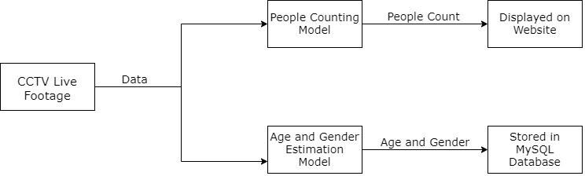

Fig 2.1 Block Diagram

## SYSTEM REQUIREMENTS

The following are the system requirements:

## USER CHARACTERISTICS:

There are mainly two users for this application. One is the end user who uses this application to generate summary for a given source file whereas the other user is admin who manages the smooth flow of this application by monitoring it on a regular basis.

## SOFTWARE AND HARDWARE REQUIREMENTS:

Requirement needs to be considered for both deployment and development:

1. Hardware Requirements: –

* CPU -
* Intel Core i5/i7/i9 HQ/Z
* AMD Ryzen 5/7/9 Zen+ or later
* RAM - 4 GB or higher
* Preferable above 300 GB

1. Software Requirements: –

* Operating System: Windows 10–
* Presentation tier- HTML5, CSS3, JavaScript
* Logic tier- Python3
* Data tier- My SQL

1. Documentation: Microsoft Word-2010 1.1.4

**The major technologies used in the project is :-**

1. **Computer Vision (Object Detection)**

Python libraries and Algorithms for Object Detection, Object Tracking (people), Age & Gender estimation are

* Numpy
* OpenCV
* Dlib
* imutils
* Pre-trained Caffe Deep learning models

The algorithm used for Object Detection(people) is a hybrid approach MobileNet- SSDs+Linear SVM as it is a highly accurate object detection method without as much of the computational burden. The object tracking algorithm used is the centroid object tracking algorithm in order to track the object in a video stream.

1. **Web Technology**

The project will be using the website as the delivery mode. Crowd Count, Age & Gender of people will be stored in a database, and later, using the website, we will display the real-time information to the public.

* Front-end Technology (HTML , CSS , Bootstrap)
* Back-end Technology (Django)
* Database (MySQL)

# SYSTEM DESIGN

The system design section gives the details regarding the system architecture, modules, tables and interface for the proposed system.

## SYSTEM ARCHITECTURE

A system architecture is the conceptual model that defines the structure, behavior, and more views of a system. An architecture description is a formal description and representation of a system, organized in a way that supports reasoning about the structures and behaviors of the system.

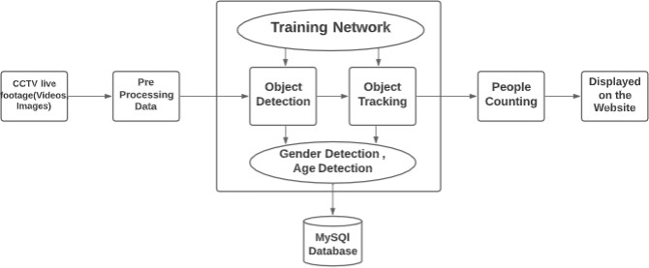

Fig 3.1 System Architecture

The proposed system architecture takes the live CCTV footage as data from the pre- installed cameras. That data will be pre processed using computer vision libraries, sent to a training network for object detection and object tracking, and then to the people

counting model, where the Age & Gender is also estimated. The people Counting model sends the data, i.e., count statistics, directly to the website and displays the crowd count. The age & Gender estimation model sends the predicted age and gender data to MySQL Database for further analysis by trading outlets.

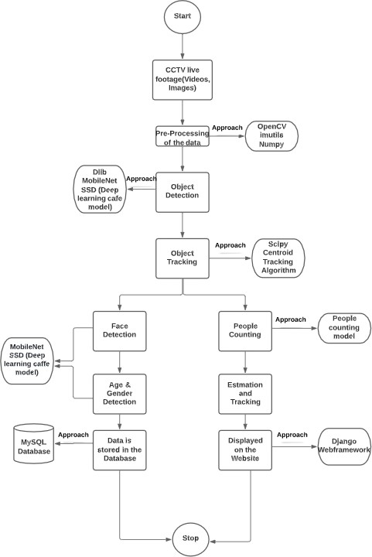

Fig 3.1.2 Flowchart of the proposed system

## MODULE DESIGN

The proposed system takes the live CCTV footage as data from the pre-installed cameras, and that data will be sent to two models, i.e., the People Counting model and Age & Gender estimation model. The people counting model helps to count the number of people, while the Age & Gender estimation model helps to predict the age and gender of the people.

The people Counting model sends the data, i.e., count statistics, directly to the website and displays the crowd count. The age & Gender estimation model sends the data, i.e., predicted age and gender, to the MySQL Database for further analysis by trading outlets.

**The following are the modules in the project**

* + CCTV live footage : It stands for Closed-Circuit Television. This is the primary module of our project. We will be extracting the real-time data from these surveillance cameras.
  + These cameras are pre-installed at every outlet at entrance and exit gates.
  + People Counting Model : This proposed model takes the raw video data from a video surveillance camera and then further processes it with the help of object detection and object tracking algorithms , thus tracing the count of people inside the outlet.
  + Age and Gender Estimation Model - This proposed model takes the raw video data from a video surveillance camera and then further processes it with the help of Age and Gender estimation algorithms to calculate age and gender of the customer.
  + Crowd Count Displayed on the Website : The website will take the count from the People Counting Model and directly display the count statistics on the outlet’s website.
  + Stored in MySQL Database: Data retrieved from Age and Gender Estimation Model will be stored in a Database like MySQL which will then be used for further processing by trading outlet’s administration.

## DATABASE DESIGN

There are three tables used for this project, namely: Customer Details, People\_In\_Outlet, People\_Exit\_Outlet in order to store the necessary information related to this project.

## TABLES AND CONSTRAINTS

The details about the database is given in detail in Tables 3.1, 3.2 and 3.3 such as the data type which each attribute follows and the description of each attribute.

Also the screenshots Fig. 3.4, 3.5, 3.6 gives the picture of how the database looks in MySQL DB.

Table 3.1 Customer Details table

|  |  |
| --- | --- |
| **Sl\_no** | (integer) serial number (row wise indexing) |
| **Gender** | (String) Gender of the Customer |
| **Minimum Age** | (integer) Minimum age of the Customer in the Range |
| **Maximum Age** | (integer) Maximum age of the Customer in the Range |

Table 3.2 People\_In\_Outlet Table

|  |  |
| --- | --- |
| **Sl\_no** | (integer) serial number (row wise indexing) |
| **People Entry**  **Time** | (Timestamp) of the people entering the Outlet |
| **People In** | (integer) People inside the outlet at that timestamp |

Table 3.3 People Exit Outlet table

|  |  |
| --- | --- |
| **Sl\_no** | (integer) serial number (row wise indexing) |
| **People Exit Time** | (Timestamp) of the people entering the Outlet |
| **People Exit** | (integer) People outside the outlet at that timestamp |

**DATABASE SCREENSHOTS**

Fig 3.4 Customer\_Details table in Database

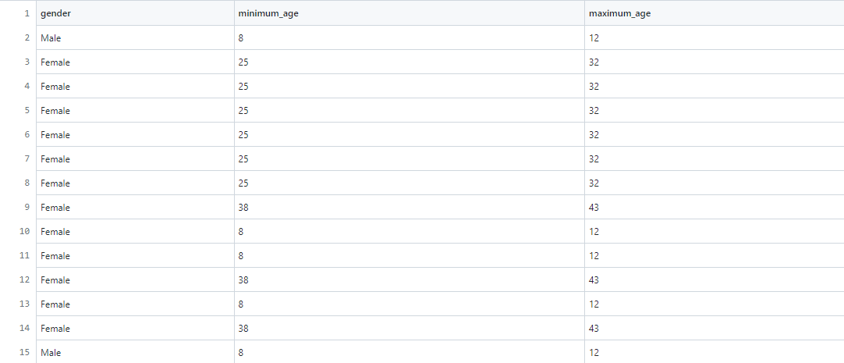

Fig 3.5 People\_In\_Outlet table in Database

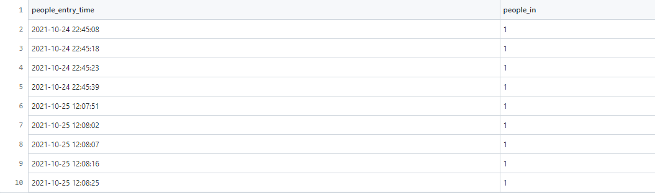

Fig 3.6 People\_Exit\_Outlet table in Database

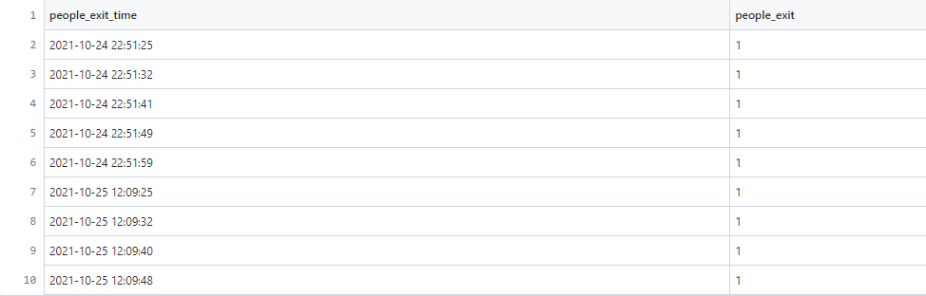

## ER DIAGRAM

An entity relationship diagram (ERD) shows the relationships of entity sets stored in a database. An entity in this context is an object, a component of data. An entity set is a collection of similar entities. These entities can have attributes that define its properties.

The Entity relationship diagram in figure 3.7 shows the relation between the different tables in the database for this project. There are mainly four tables, namely:

* + People
  + Outlet
  + Outlet’s Website
  + Database

These are the four entities that are found in the proposed system. A person entering the outlet his/her Age and Gender are the two attributes of the entity People while the outlet entity has only one attribute that is the outlet’s name. The entity outlet’s website

where people visit displays the crowd count of the outlet. The entity outlet stores data in the entity database which is connected to the attribute MySQL.

**Attributes:**

* Age: Age of the person
* Gender: Gender of the person.
* Outlet Name: Name of the outlet
* MySQL: Database of the Outlet

**Entity Relationship Types**

* The relationship between People and Outlet is many to one as the system can have many customers visiting one outlet.
* The relationship between People and Outlet’s Website is many to one as the system can have many customers visiting the Outlet’s Website.
* The relationship between Outlet and Outlet’s Website is one to one as one outlet will have its own outlet’s Website which displays the crowd count.
* The relationship between Outlet and Database is one to one as the system can have one Database for one which stores the data in MySQL.

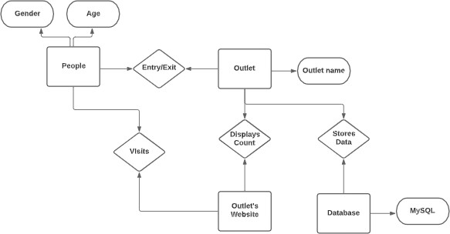

Fig 3.7 ER Diagram

## DATAFLOW DIAGRAM

**DFD level 0**

Figure 3.8 is a simple representation to show the brief functionalities and the external entities in the project (people and outlet). The function shows the major task that this project focuses on which is people count.

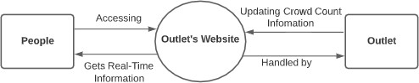

Fig 3.8 DFD level 0

**DFD level 1**

The level one diagram shown in Fig 3.9 gives a quick view of the divided functionalities when the application’s process is examined deeply

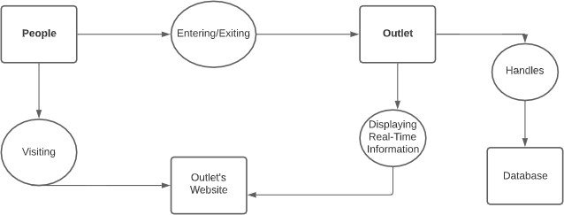

Fig 3.9 DFD level 1

**DFD level 2**

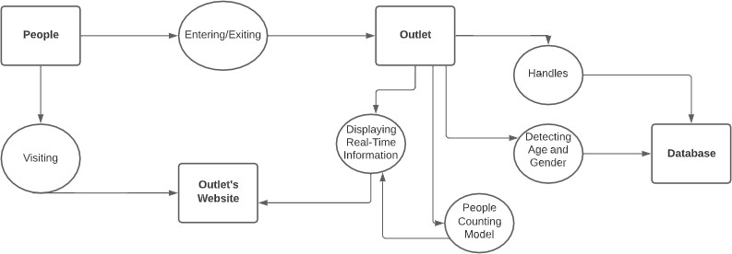Figure 3.10 gives a more in depth view of how each process occurs such as the order and its respective connection to the data base.

Fig 3.10 DFD level 2

## INTERFACE DESIGN AND PROCEDURAL DESIGN

The following shows the interfaces and flow diagram for the proposed project.

## USER INTERFACE DESIGN

The user interfaces for the web application of the proposed project is as follows:

****

Fig 3.11 Home page

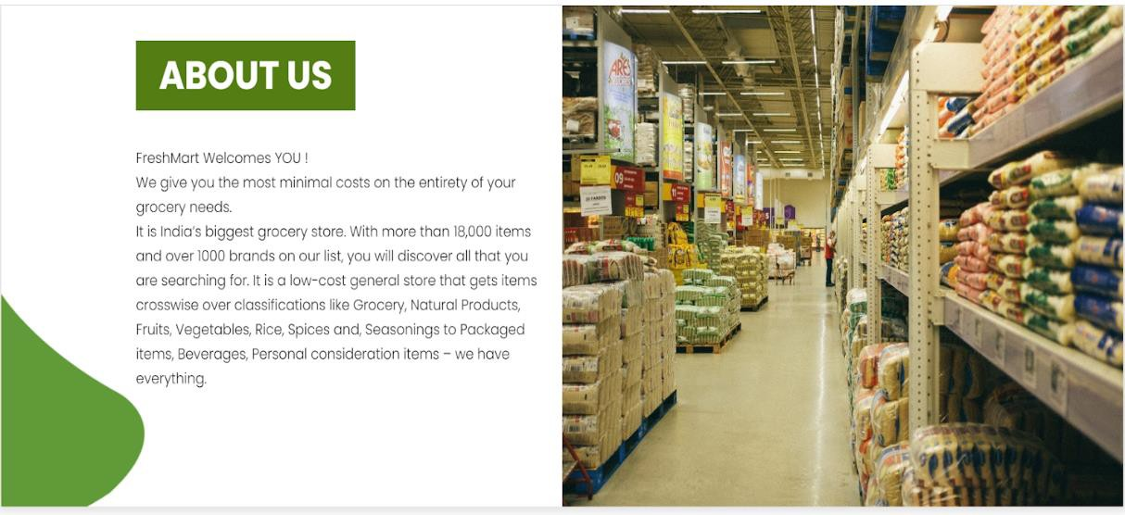

Fig 3.12 About Page



Fig 3.13 Our promise page design of the website



Fig 3.14 Testimonial page design of the website

Fig 3.15 Our store page design of the website

# IMPLEMENTATION

This section gives details regarding how the project is implemented, the algorithms, code and their respective screenshots.

## IMPLEMENTATION ALGORITHMS

This project uses three main algorithms:

1. **MobileNet SSD**

The MobileNet-SSD model is a Single-Shot Multibox Detection (SSD) network intended to perform object detection. This model is implemented using the Caffe\* framework.

SSD Object Detection extracts feature map using a base deep learning network, which is a CNN-based classifier and applies convolution filters to finally detect objects.

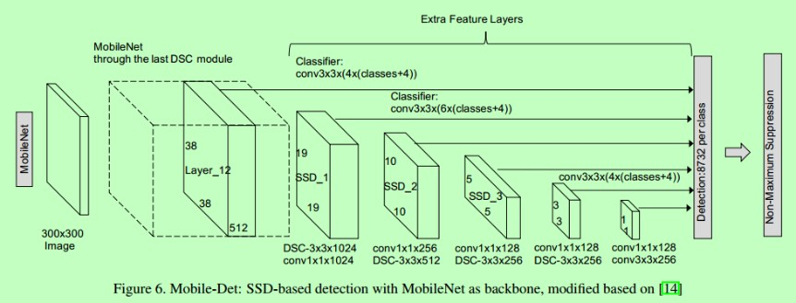In the proposed system the MobileNet SSD is used for object detection, especially face, and age detection.

Fig 4.1 MobileNet SSD Architecture

1. **Centroid Tracking Algorithm**

The detected objects can be tracked by an object tracker to track the object as it moves around the frame. The object tracker should be faster and more efficient than the object detector and should continue tracking until it has reached the N-th frame and then re-run the object detector. The entire process then repeats. The centroid tracking algorithm is a multi-step process.

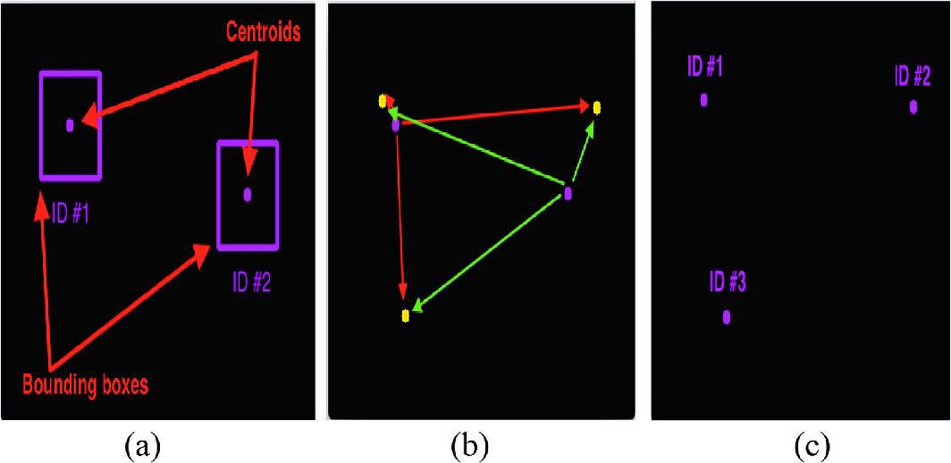

Fig 4.2 Centroid Tracking Algorithm steps

1. Accept bounding box coordinates and compute centroids

The centroid tracking algorithm assumes that the person is passing in a set of the bounding box (x, y)-coordinates for each detected object in every single frame. These bounding boxes can be produced by any type of object detector, provided that they are computed for every frame in the video.

1. Compute Euclidean distance between new bounding boxes and existing objects

Three objects are present in this image for simple object tracking with Python and OpenCV. We need to compute the Euclidean distances between each pair of original centroids (red) and new centroids (green).

1. Update (x, y)-coordinates of existing objects and Register new objects

The centroid object tracking method has associated objects with minimized object distances. The primary assumption of the centroid tracking algorithm is that a given object will potentially move in between subsequent frames, but the distance between the centroids for frames F_t and F_{t + 1} will be smaller than all other distances between objects. a new object that wasn’t matched with an existing object, so it is registered as object ID

1. **People Counting Algorithm**

The method to figure out if the object (person) is moving in or out is by grabbing the y-coordinate value for all previous centroid locations for the given object and computing the direction by taking the difference between the current centroid location and the mean of all previous centroid locations.

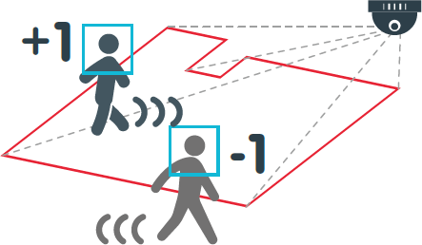Therefore, by taking the mean, the people's counter can be more accurate. If the TrackableObject has not been counted then in order to determine if it’s ready to be counted yet by:

Fig 4.3 People counter system

* Checking if the direction is negative (indicating the object is moving IN) AND the centroid is Above the centerline. In this case, we increment the totalIN.
* Or checking if the direction is positive (indicating the object is moving OUT) AND the centroid is below the centerline. If this is true, we increment totalOUT.

## CODING DETAILS

**Few of the main codes used in this project are:**

**4.2.1 People Entering Outlet**

**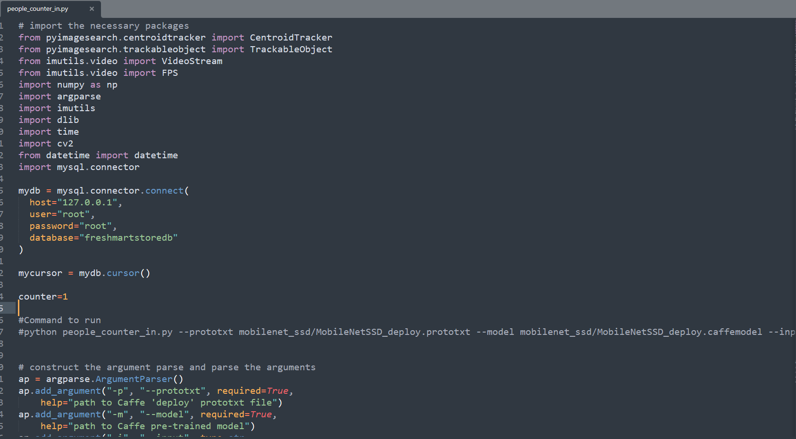**

Fig 4.4 People Entering Outlet Code

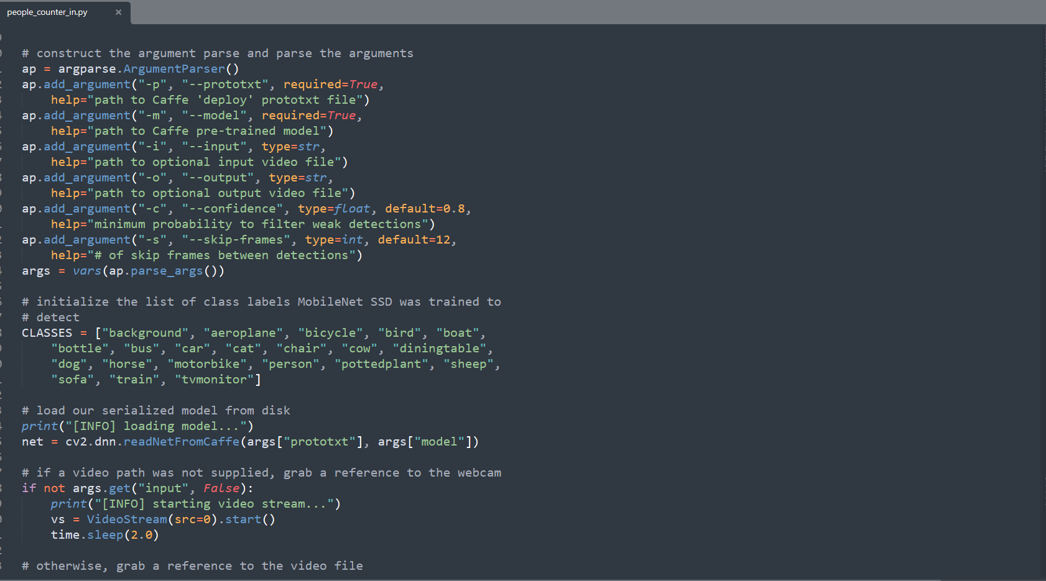Fig 4.5 People Entering Outlet Code

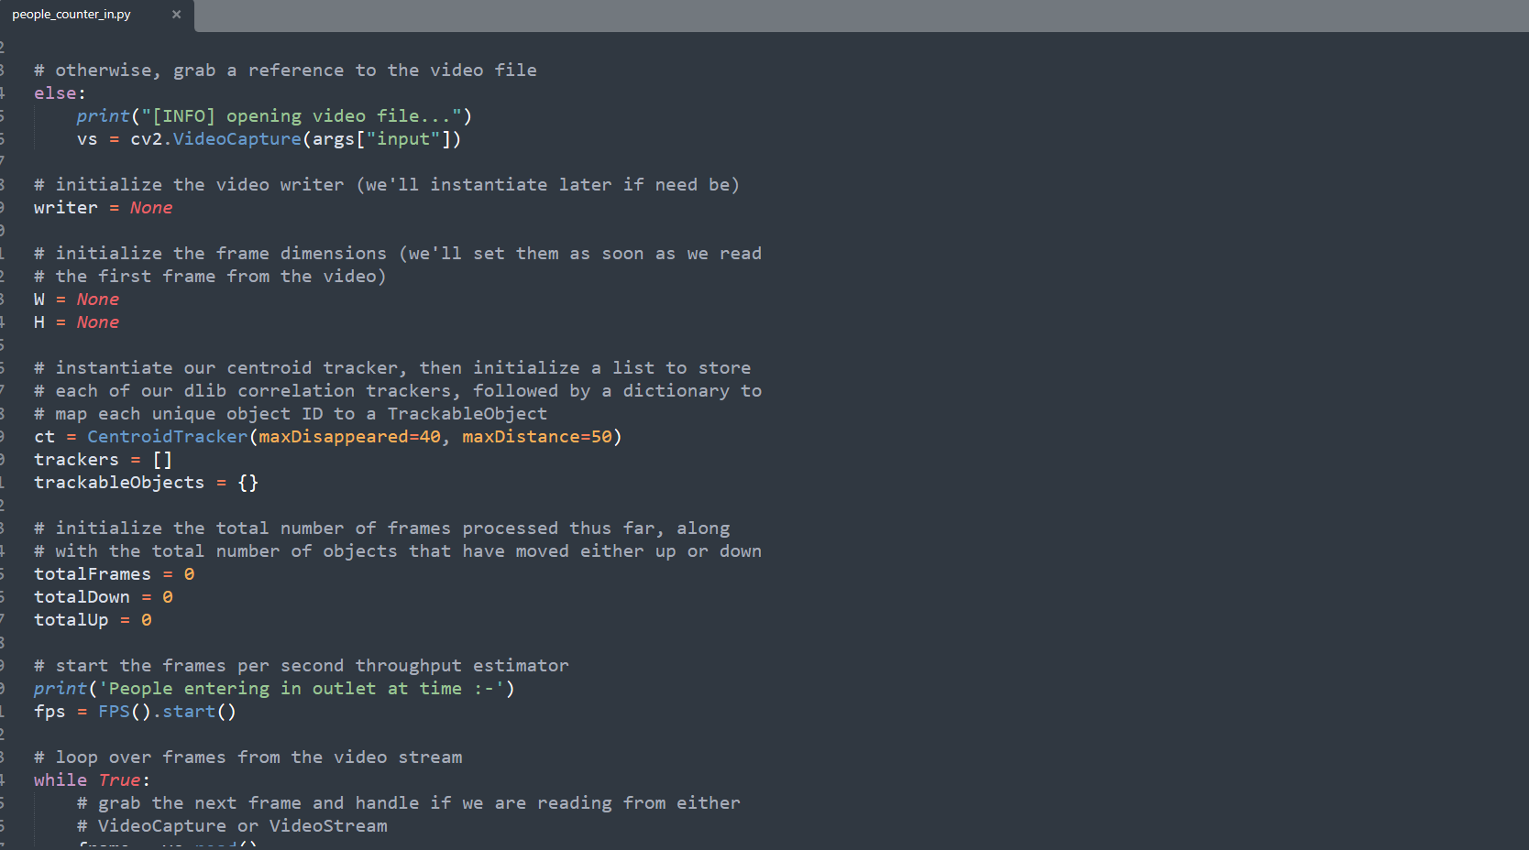

Fig 4.6 People Entering Outlet Code

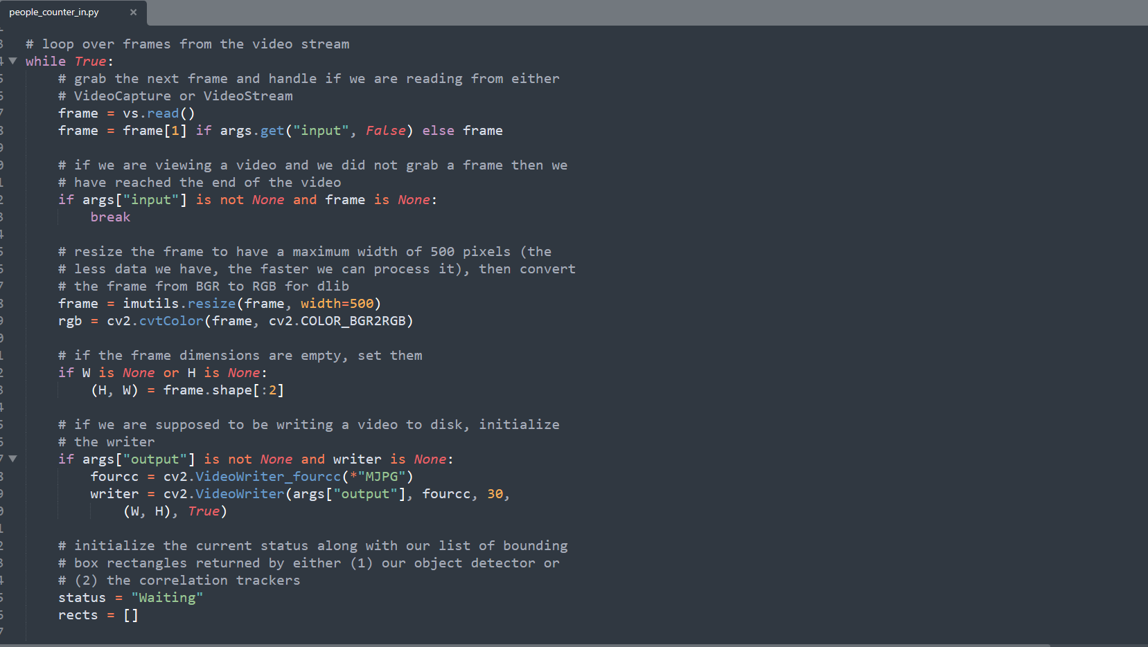

Fig 4.7 People Entering Outlet Code

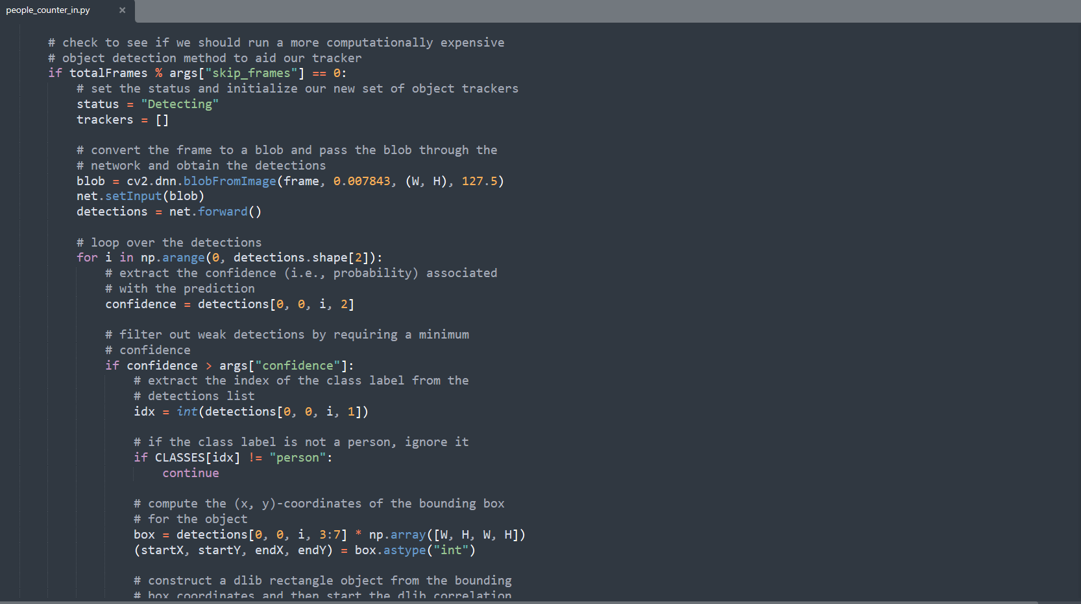

Fig 4.8 People Entering Outlet Code

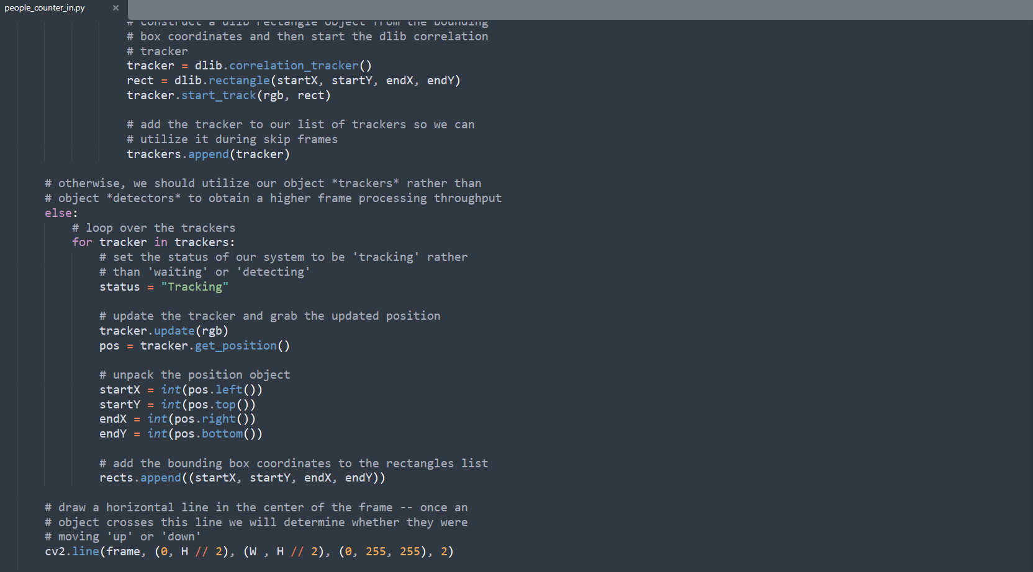

Fig 4.9 People Entering Outlet Code

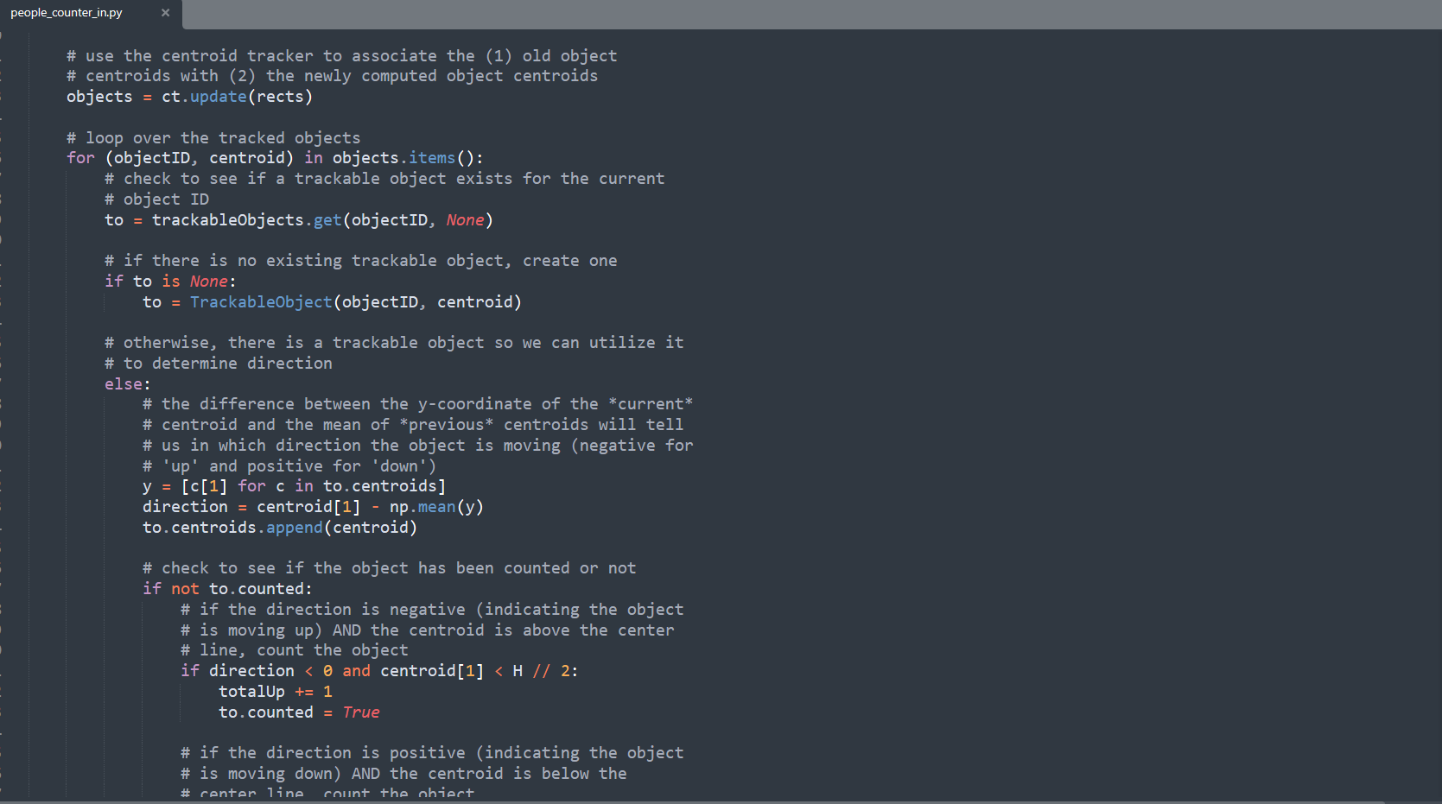

Fig 4.10 People Entering Outlet Code

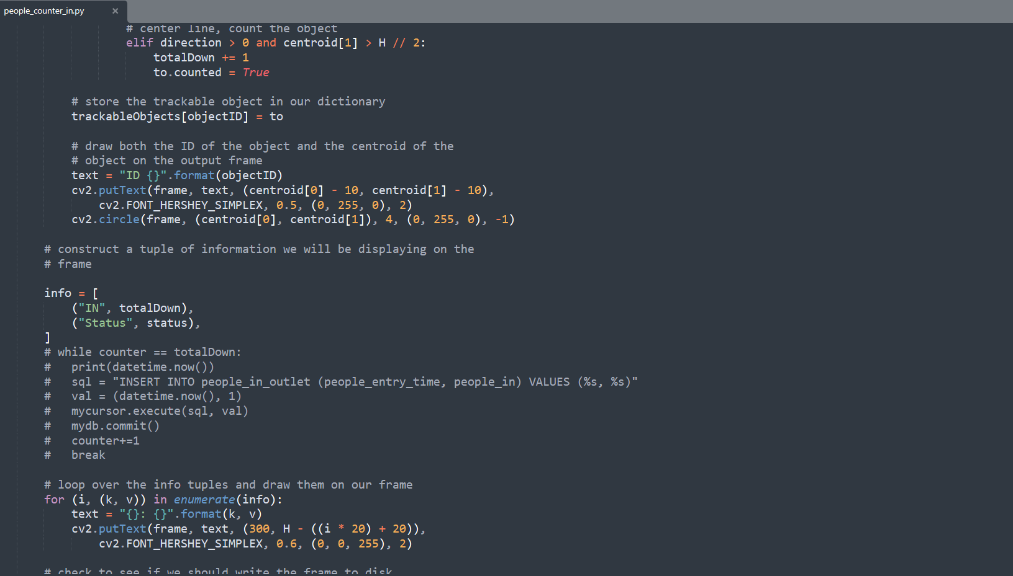

Fig 4.11 People Entering Outlet Code

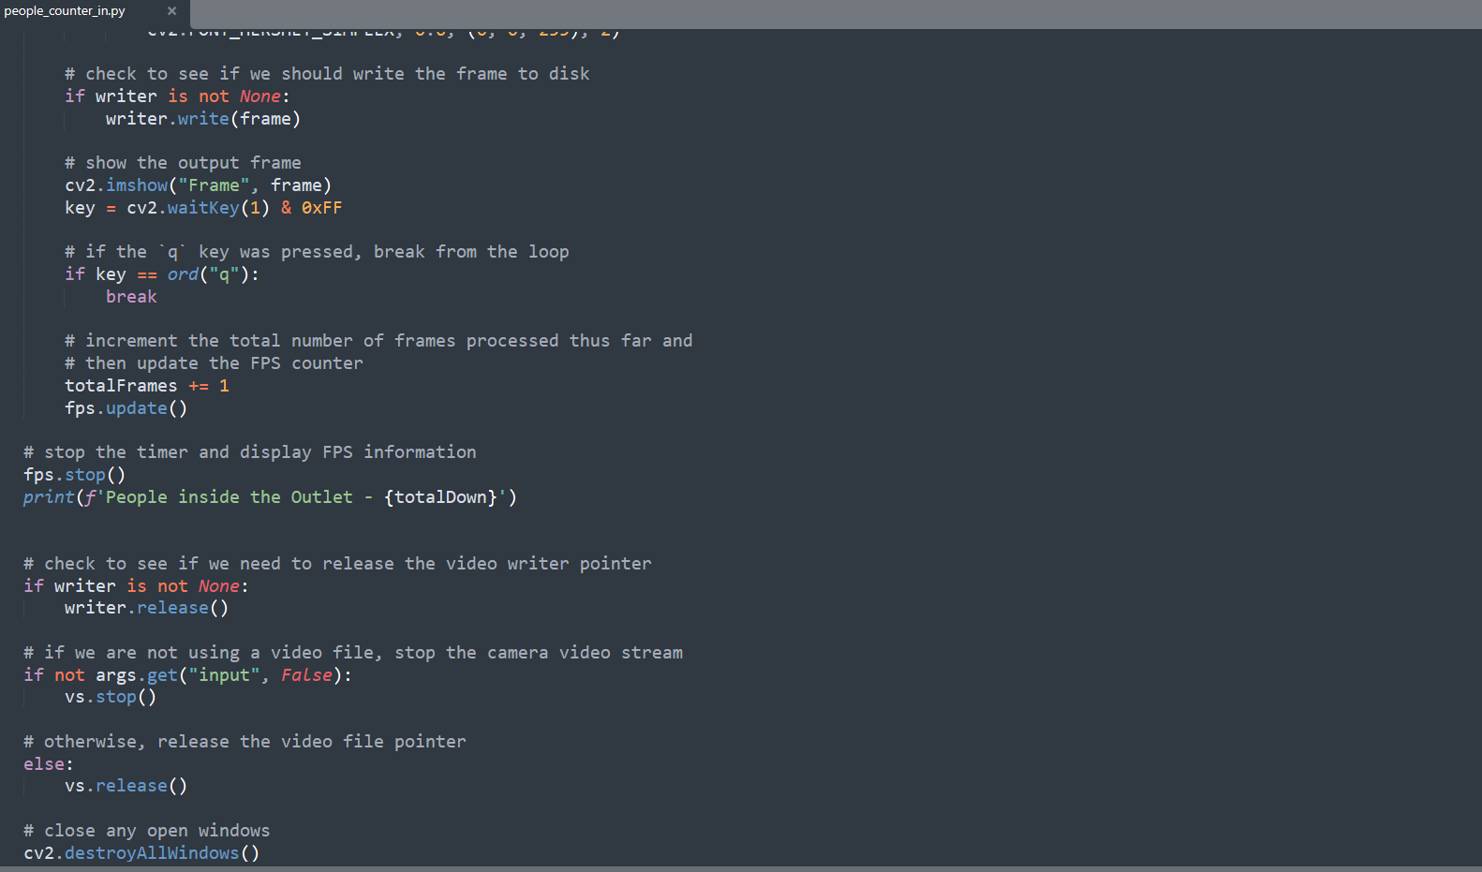

Fig 4.12 People Entering Outlet Code

* + 1. **People Exiting Outlet**

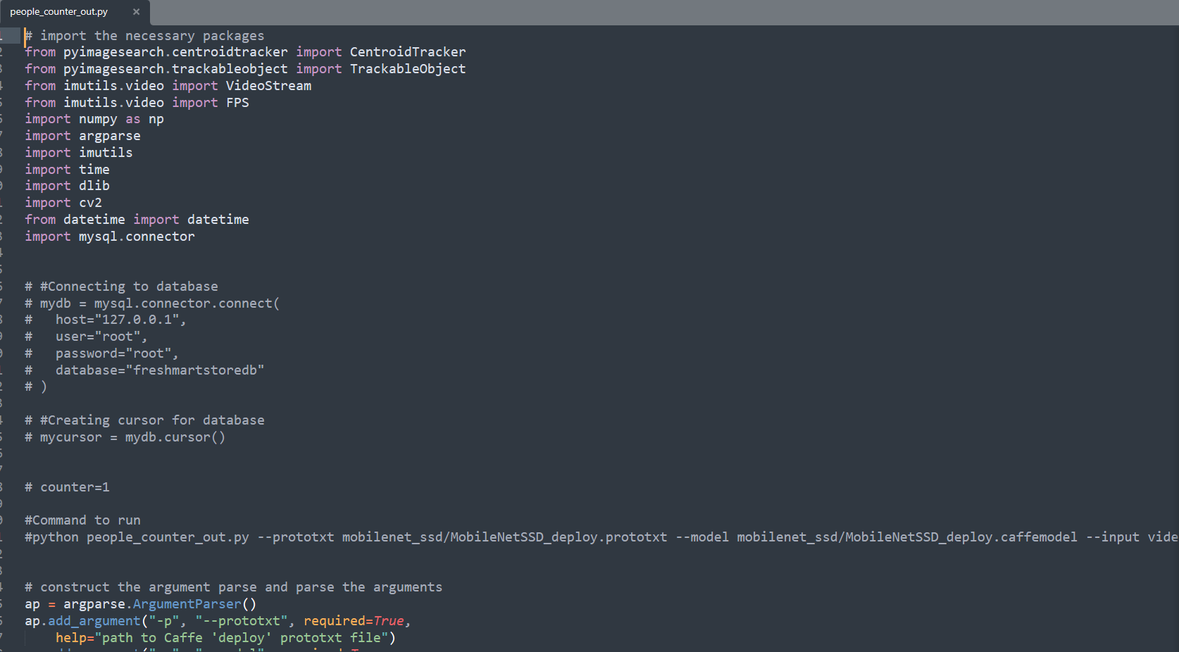

Fig 4.13 People Exiting Outlet Code

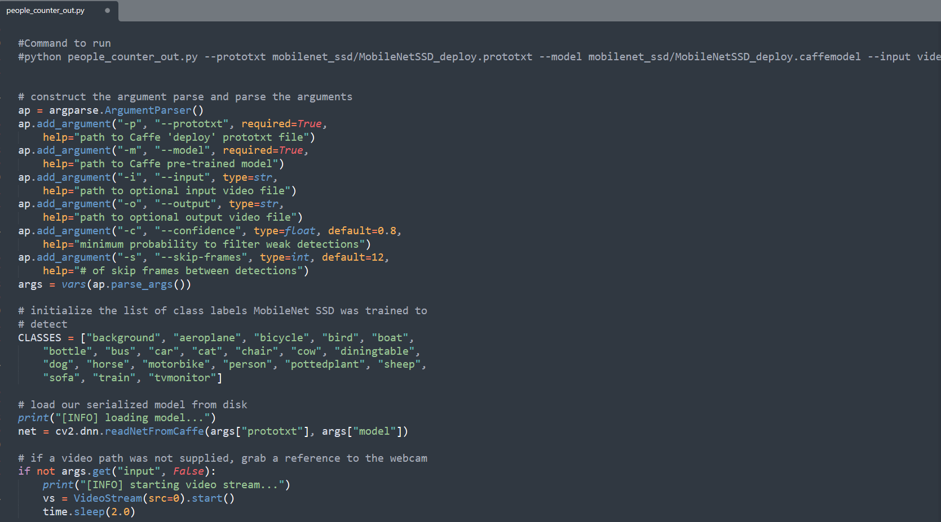

Fig 4.14 People Exiting Outlet Code

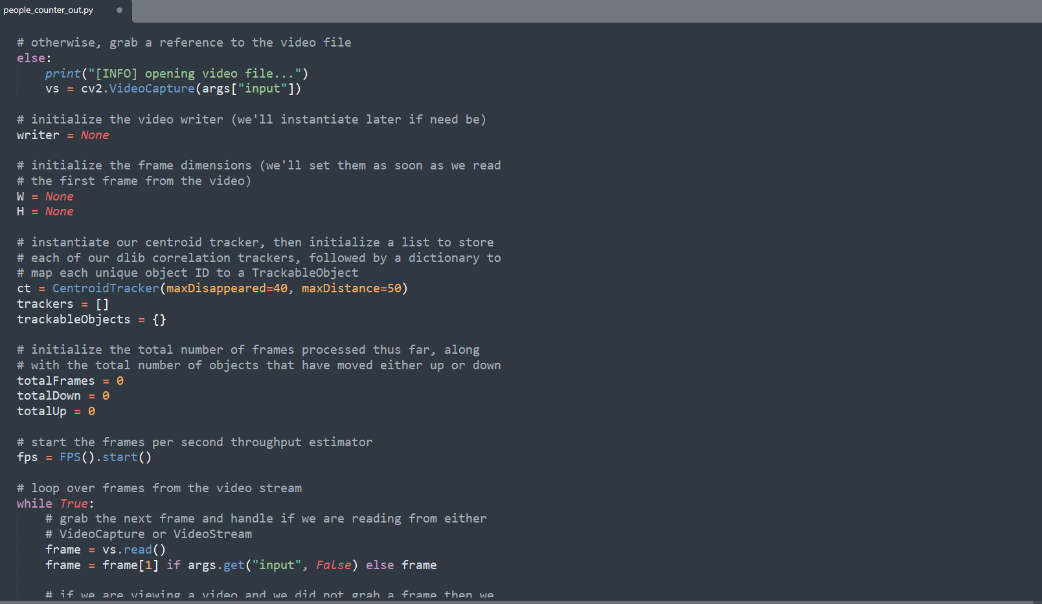 Fig 4.15 People Exiting Outlet Code

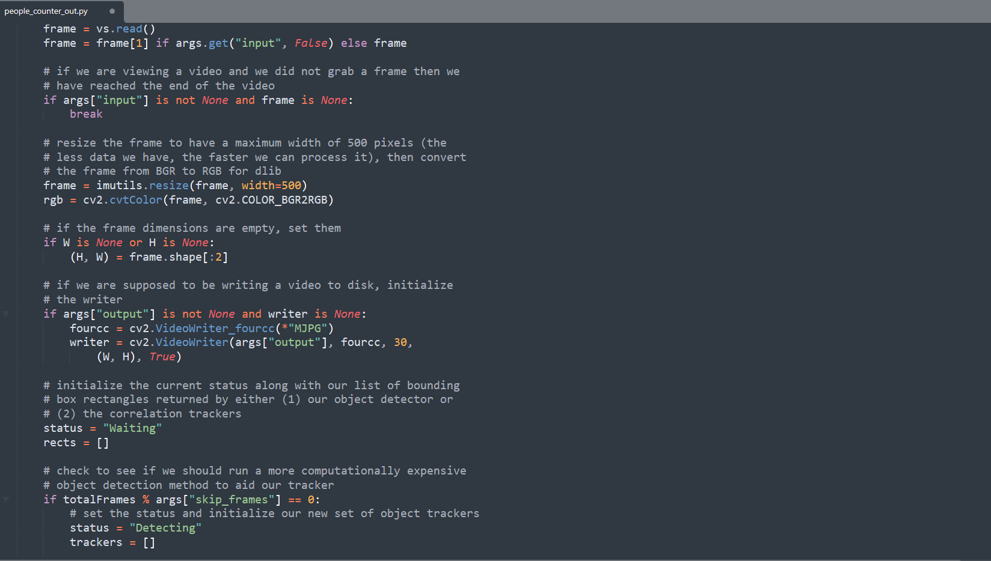

Fig 4.16 People Exiting Outlet Code

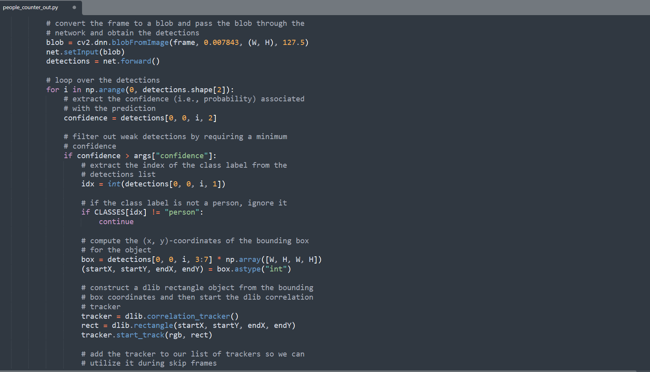

Fig 4.17 People Exiting Outlet Code

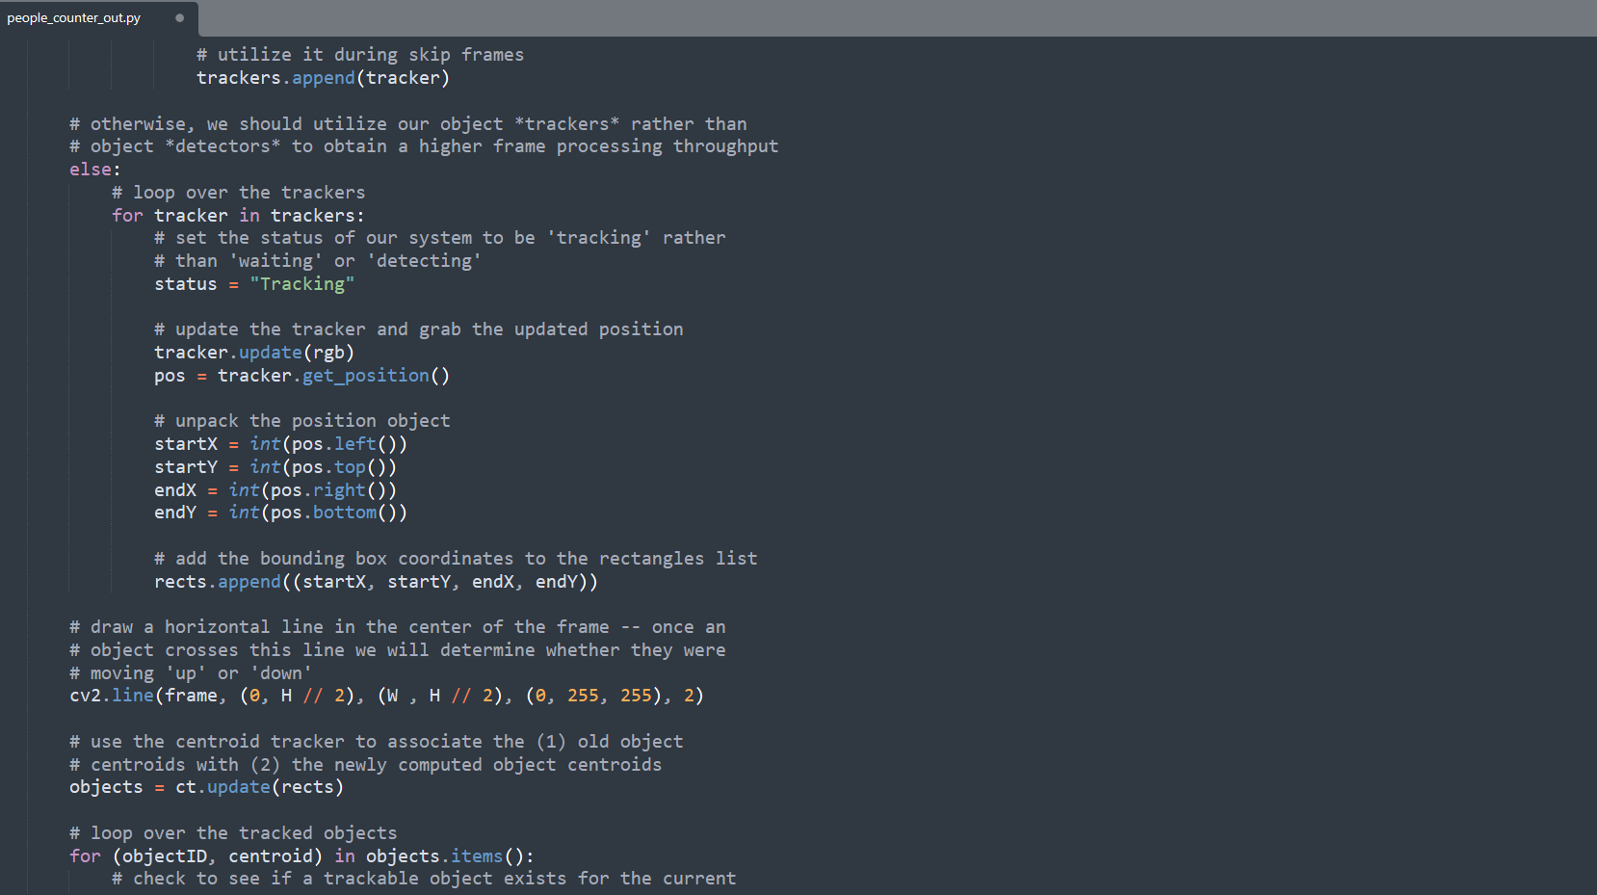Fig 4.18 People Exiting Outlet Code

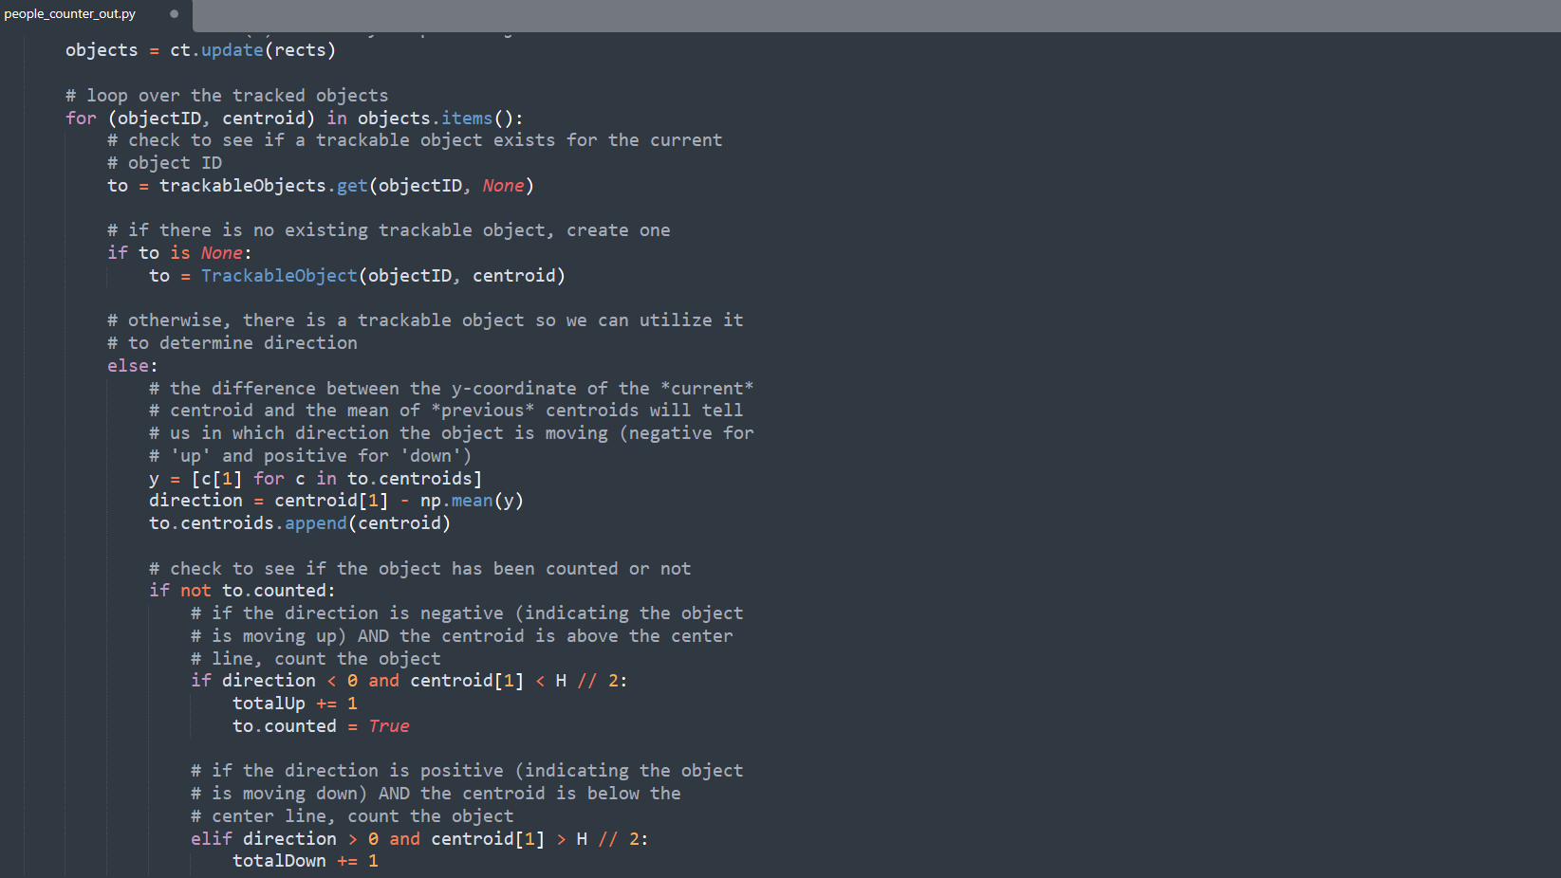

Fig 4.19 People Exiting Outlet Code

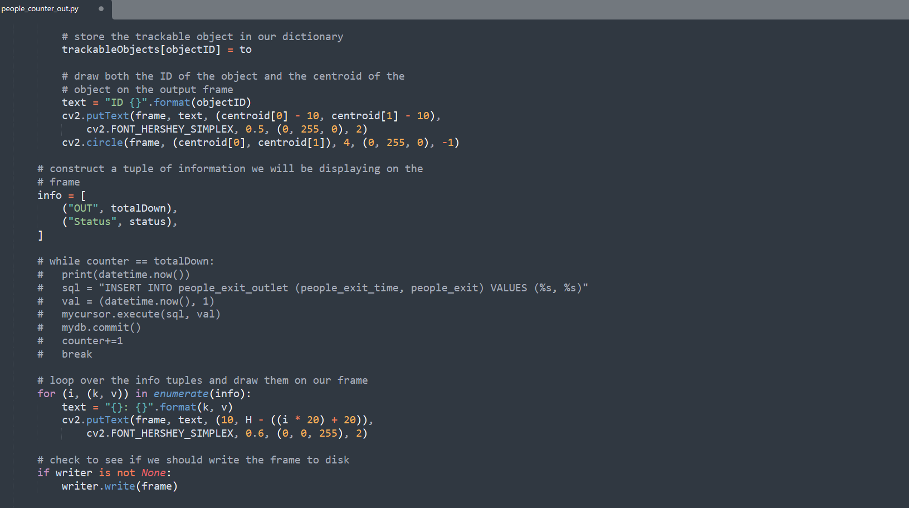

Fig 4.20 People Exiting Outlet Code

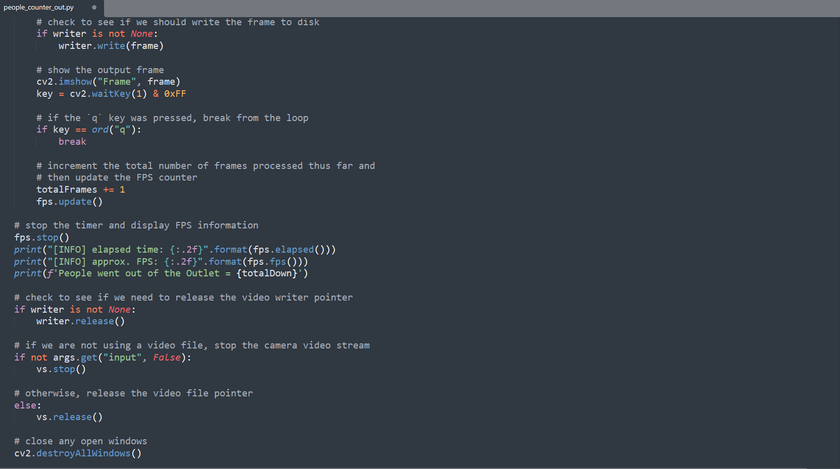

Fig 4.21 People Exiting Outlet Code

* + 1. **Age and Gender Detection**

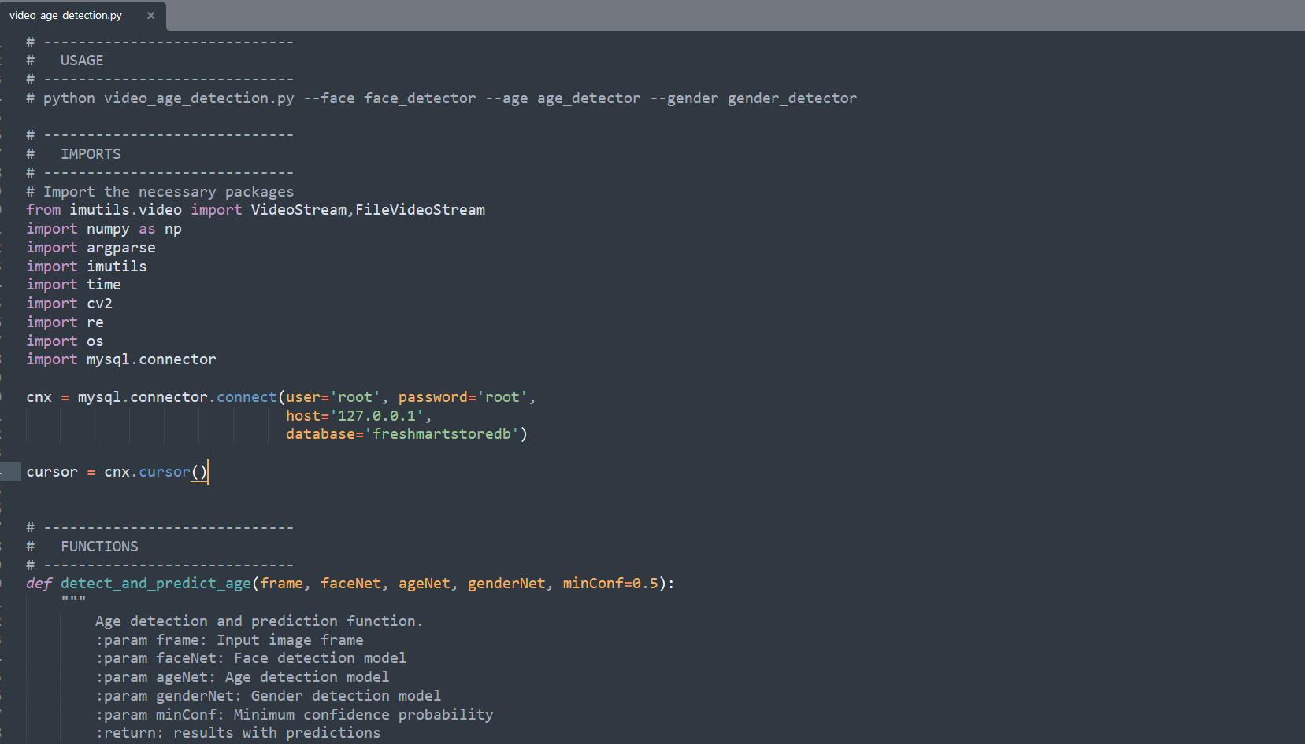Fig 4.22 Age and Gender Detection Code

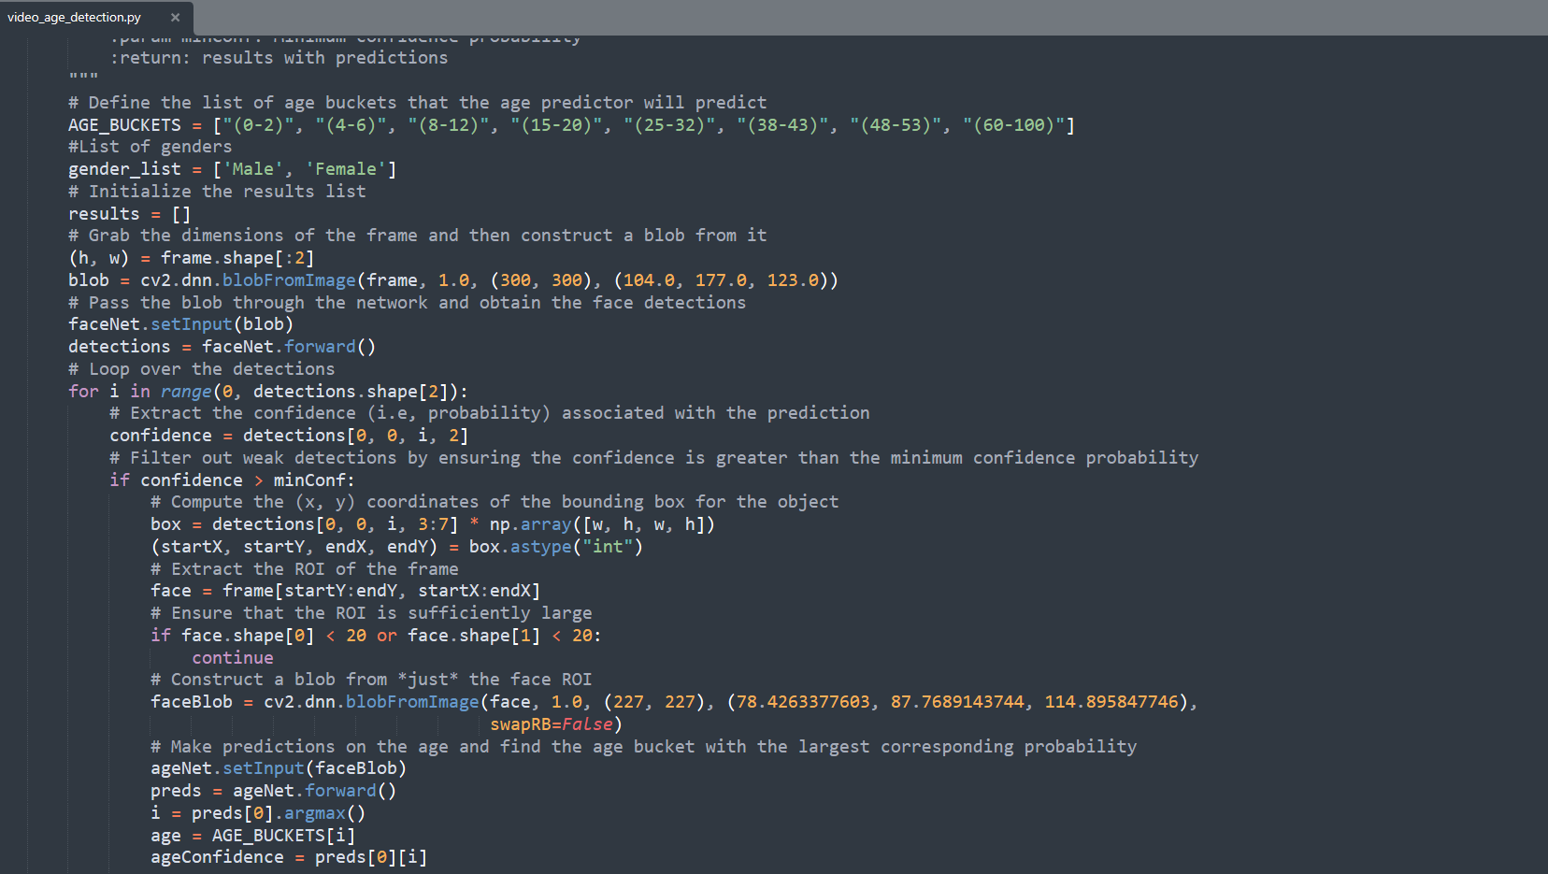

Fig 4.23 Age and Gender Detection Code

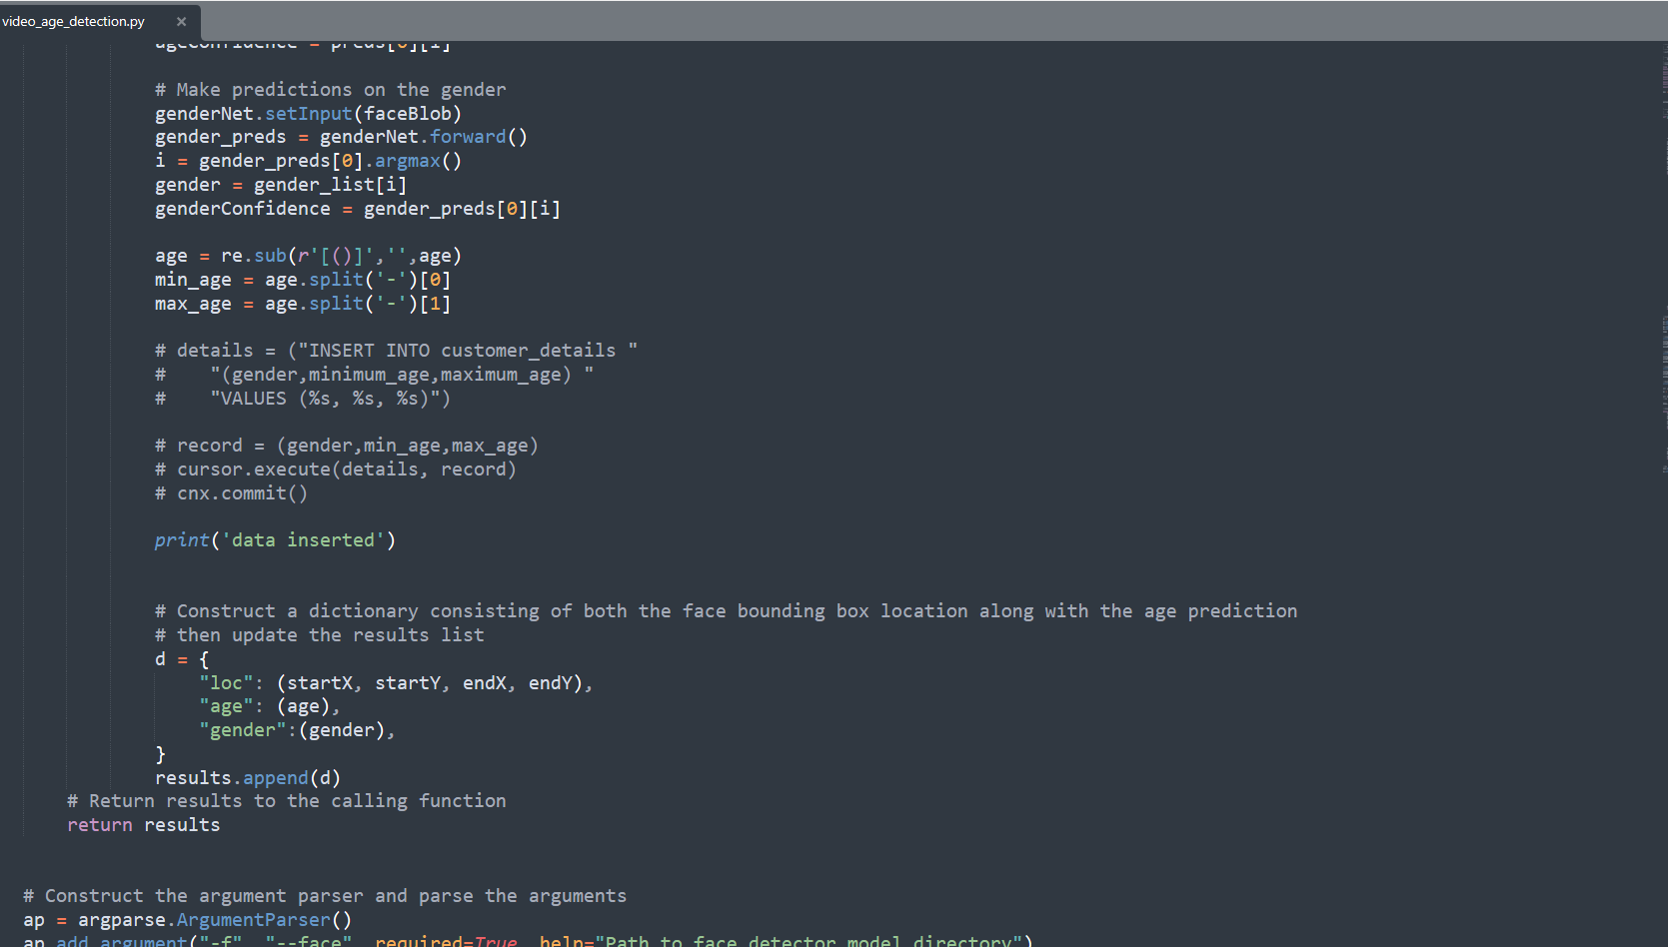

Fig 4.24 Age and Gender Detection Code

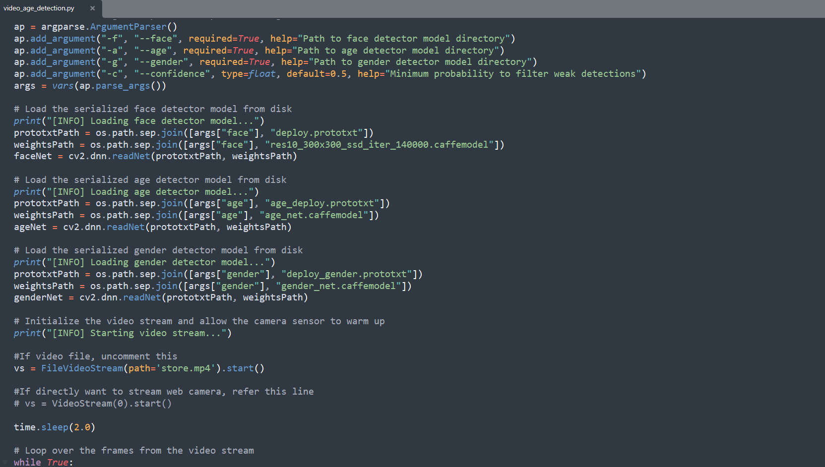 Fig 4.25 Age and Gender Detection Code

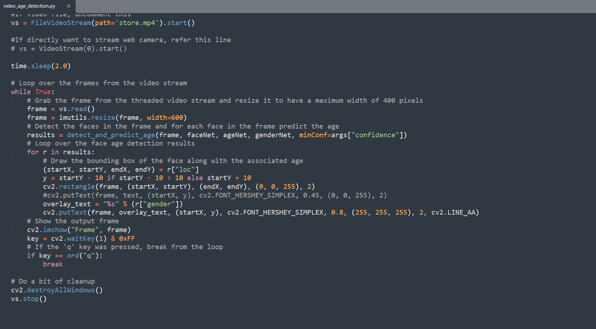

Fig 4.26 Age and Gender Detection Code

* + 1. **Website Code (Index.html)**

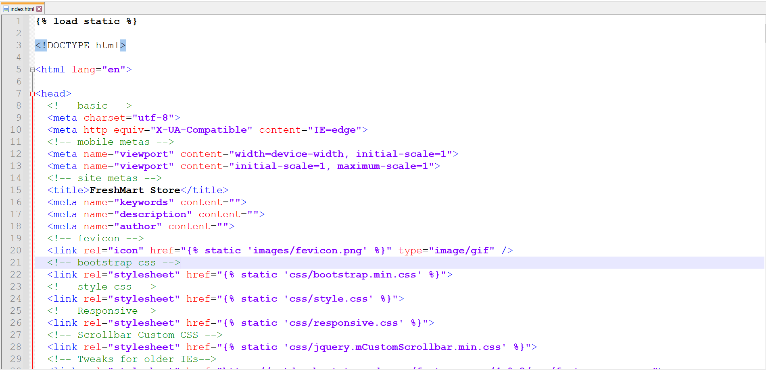

Fig 4.27 Index.html

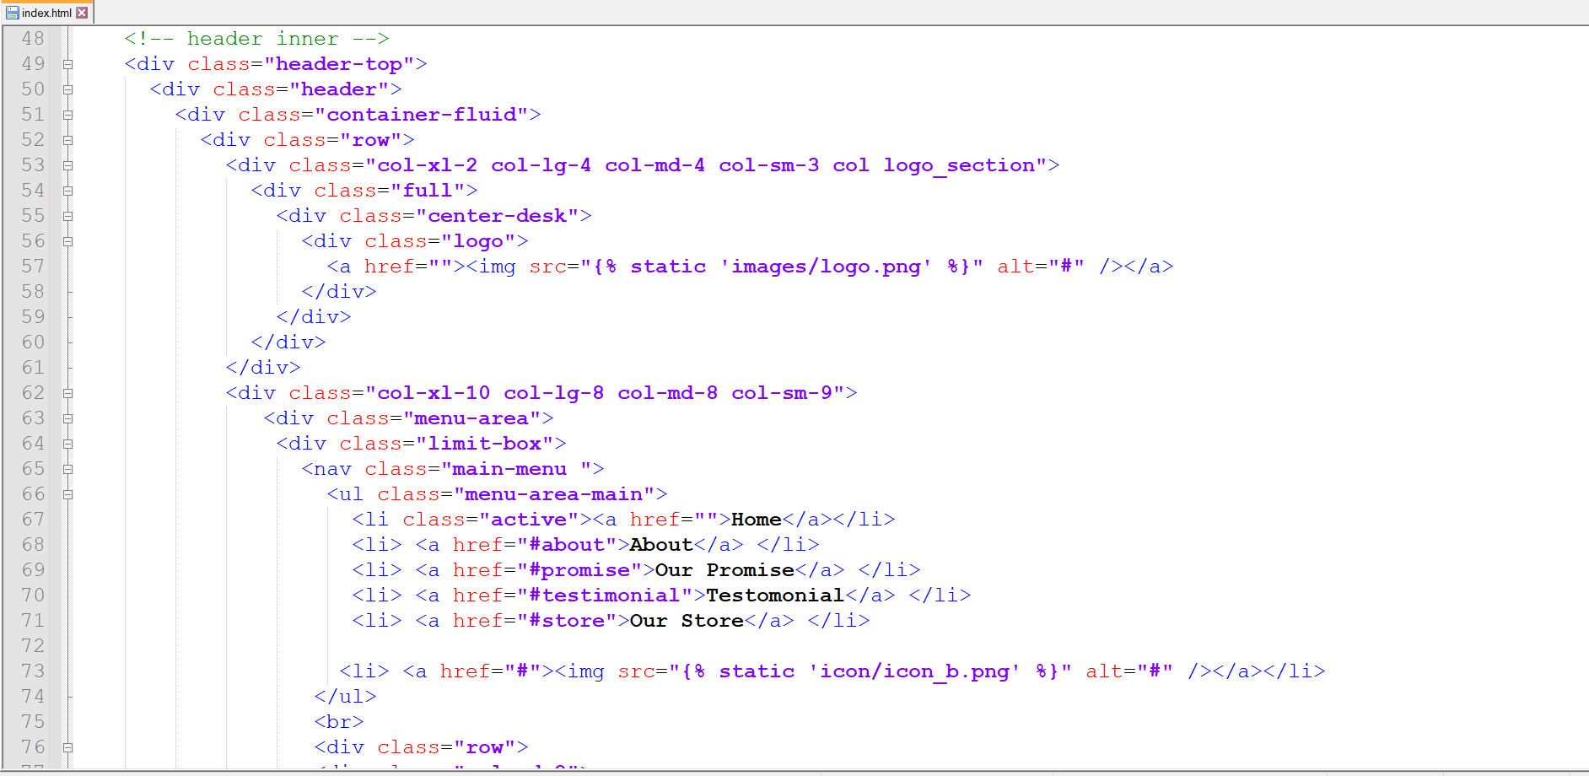

Fig 4.28 Index.html

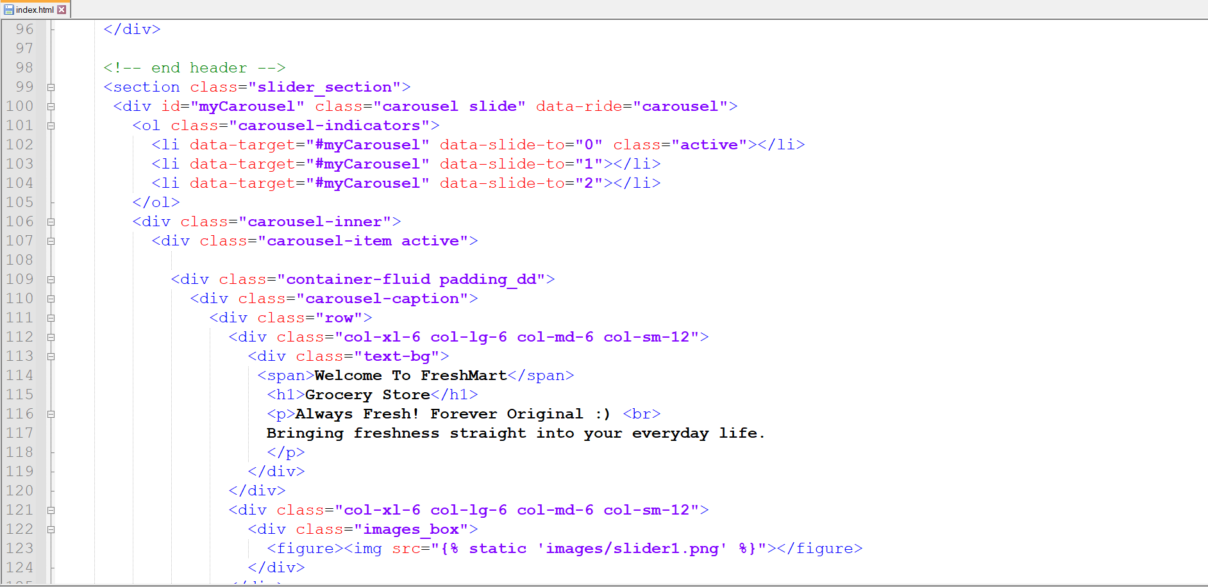

Fig 4.29 Index.html

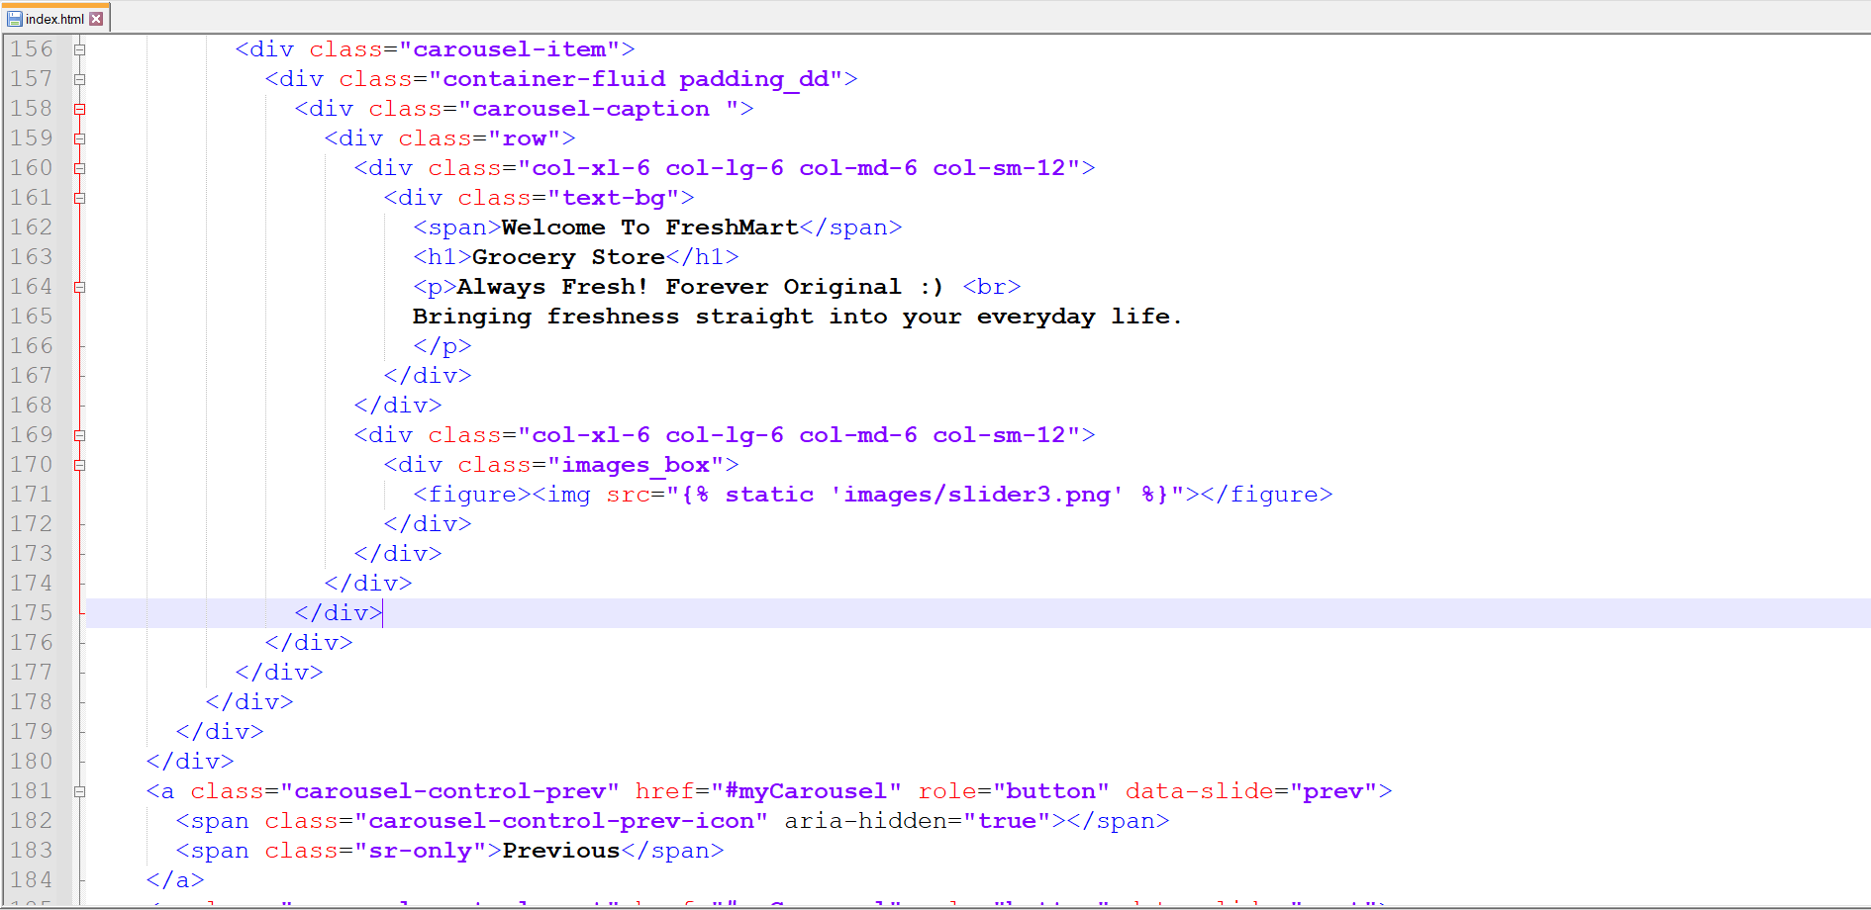

Fig 4.30 Index.html

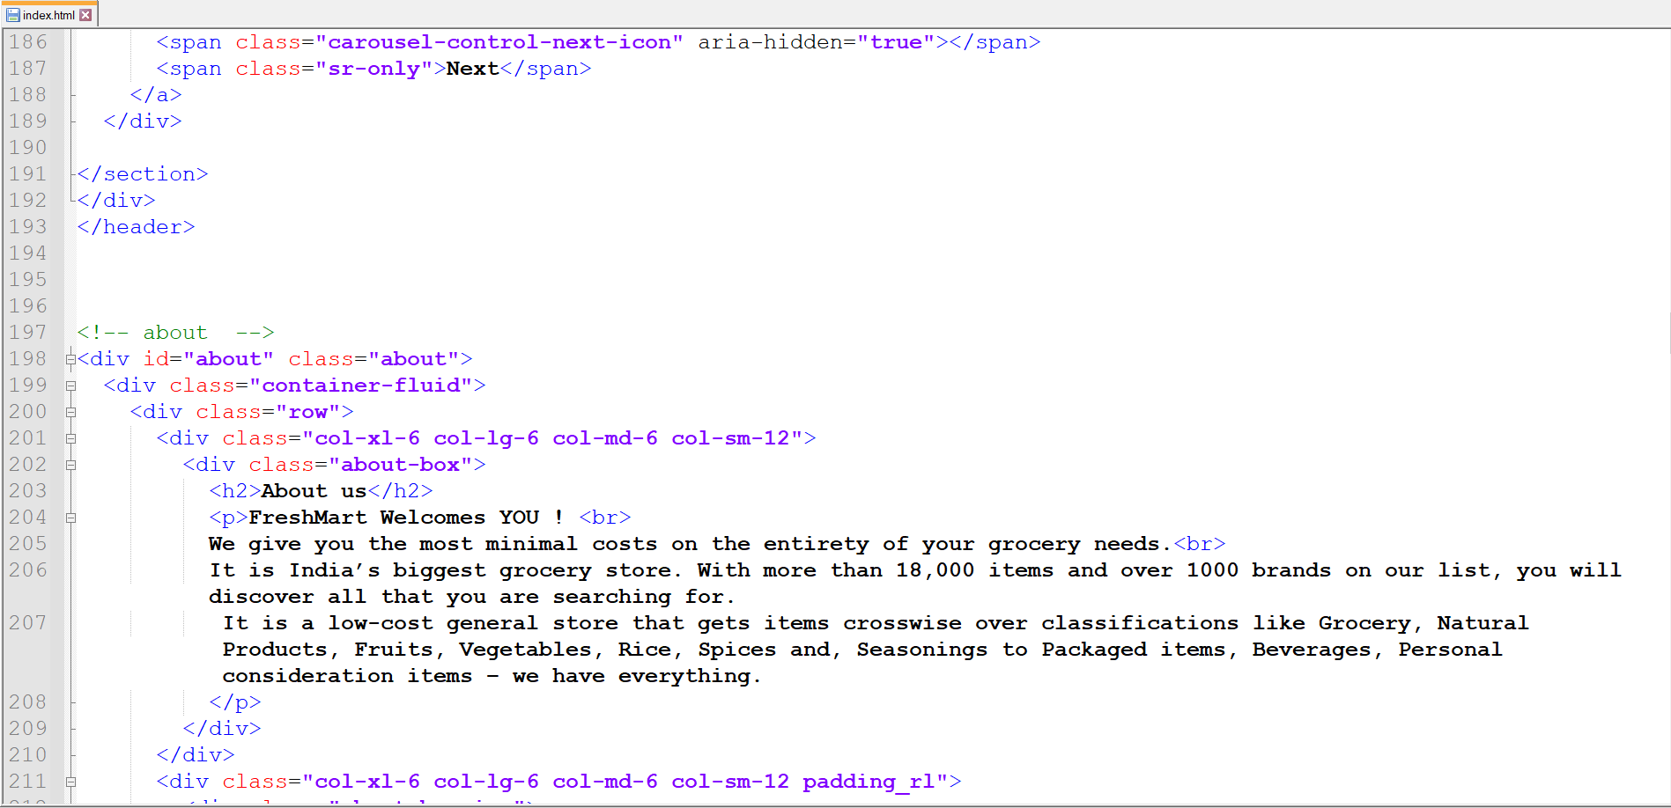

Fig 4.31 Index.html



Fig 4.32 Index.html

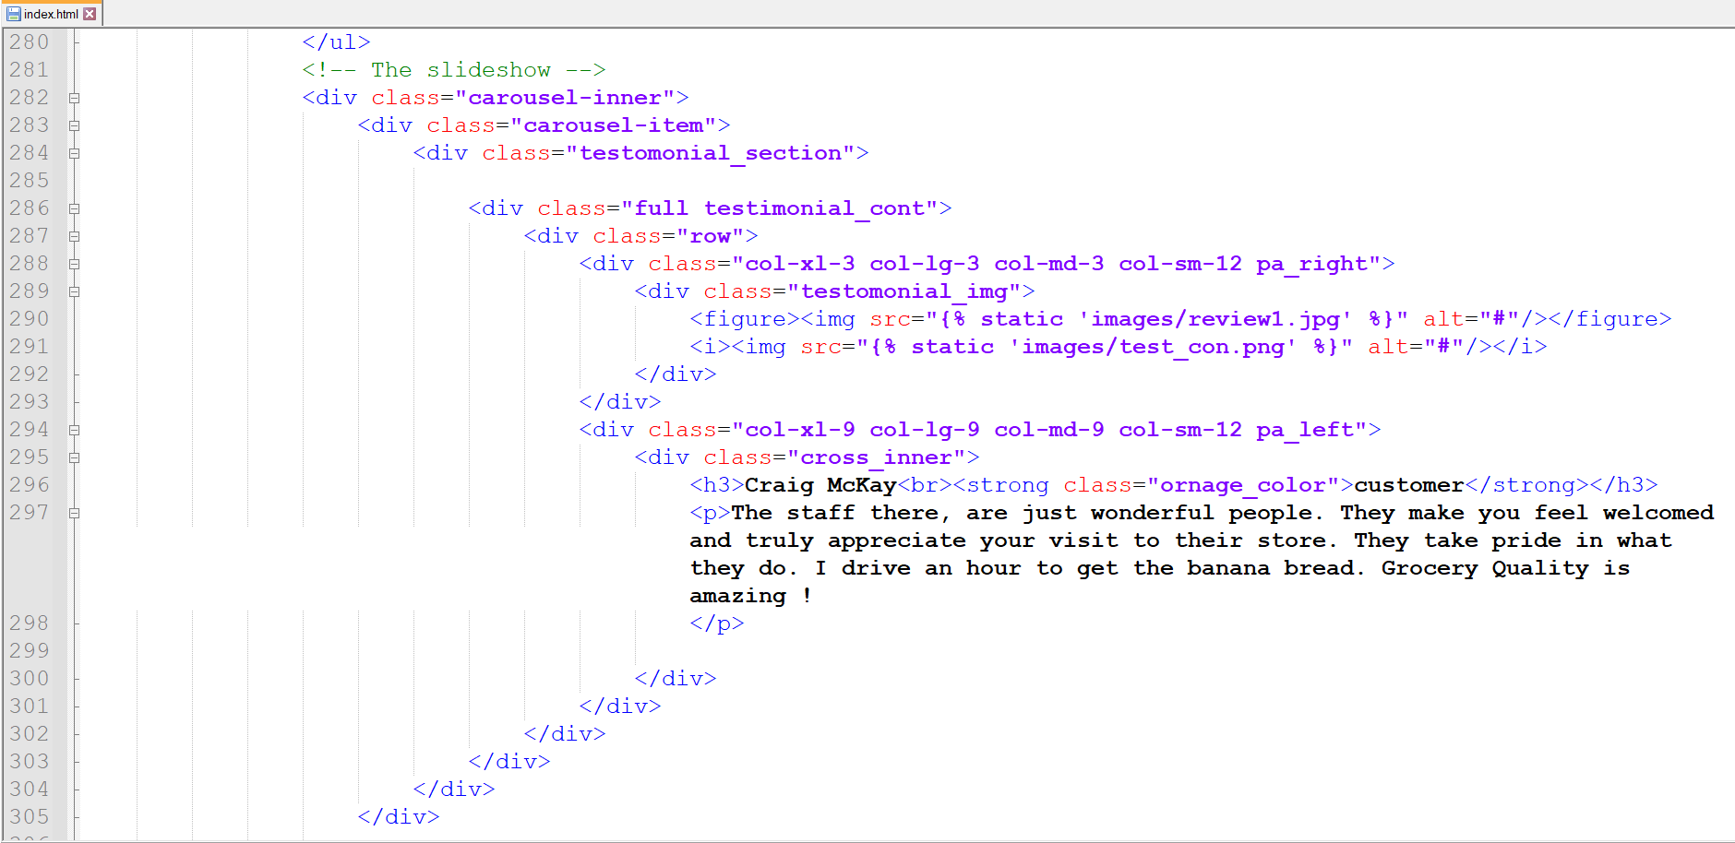

Fig 4.33 Index.html

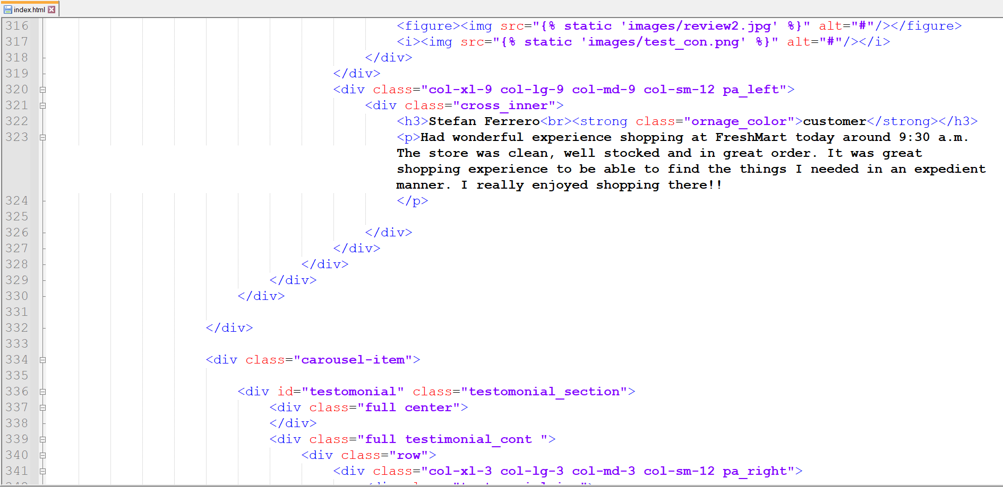

Fig 4.34 Index.html

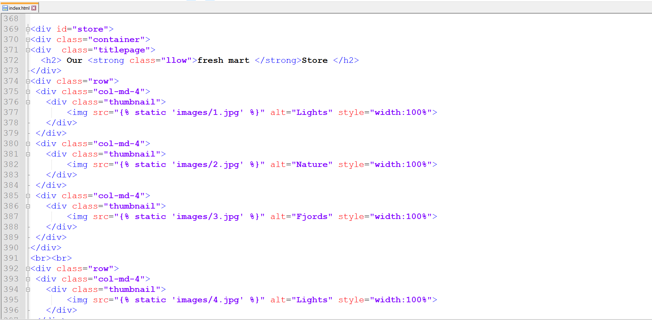

Fig 4.35 Index.html

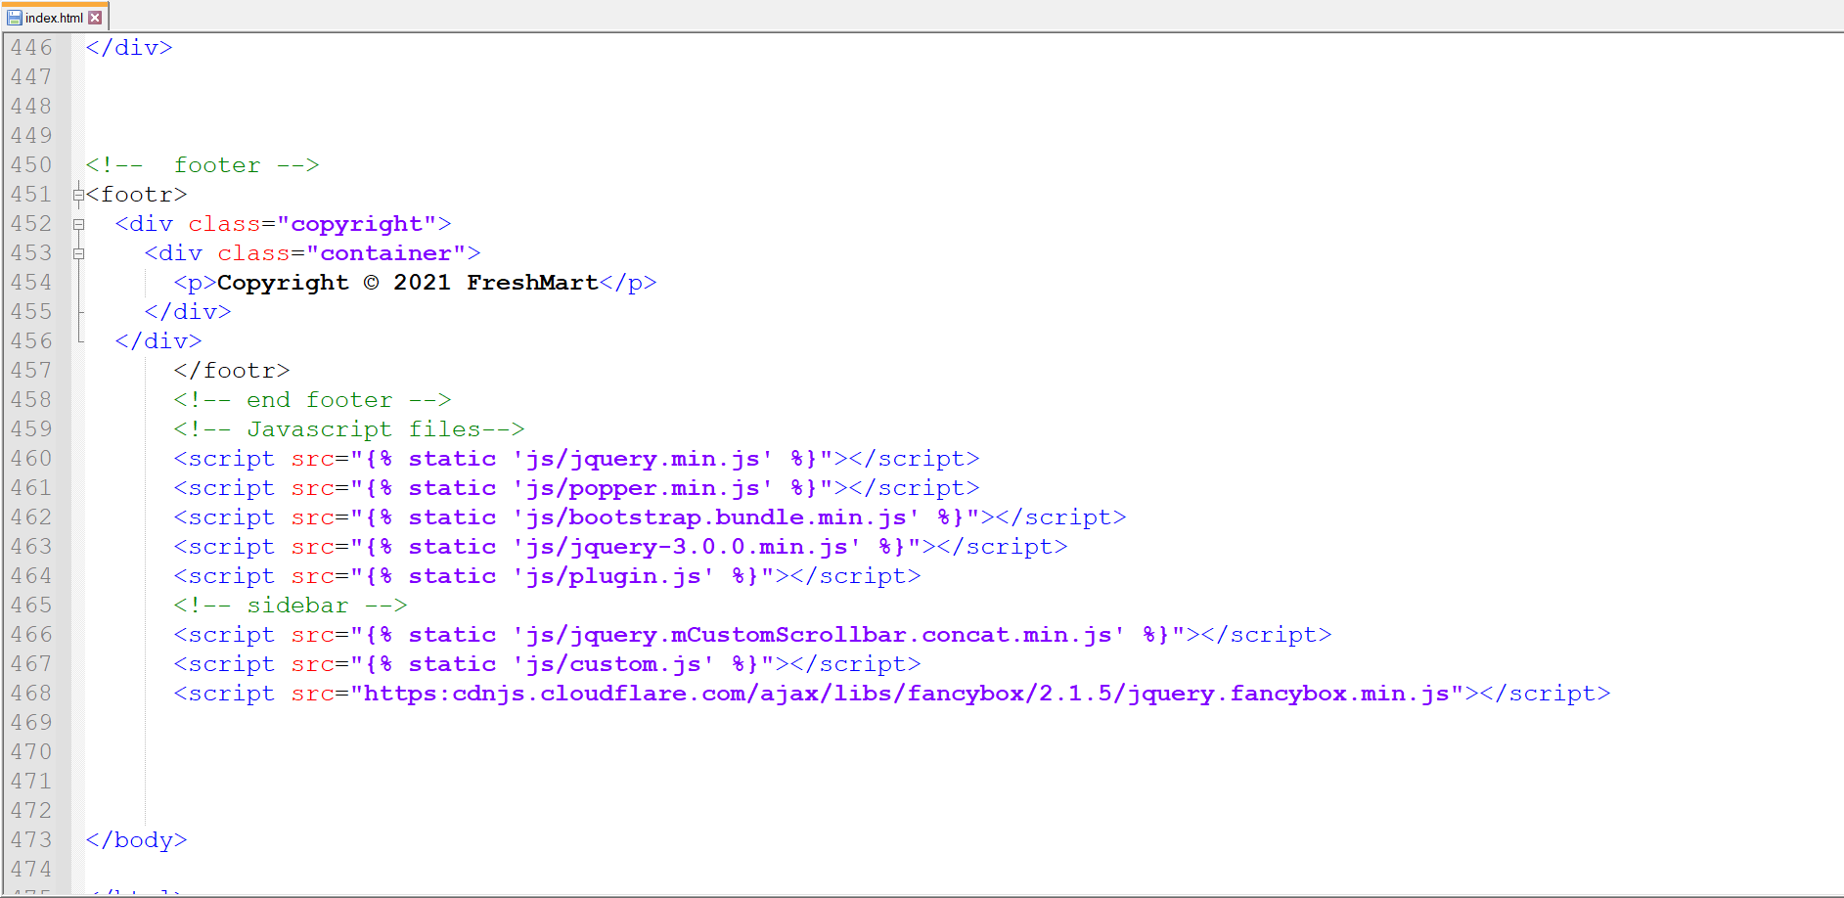

Fig 4.36 Index.html

* + 1. **Website Code (Django Code)**

**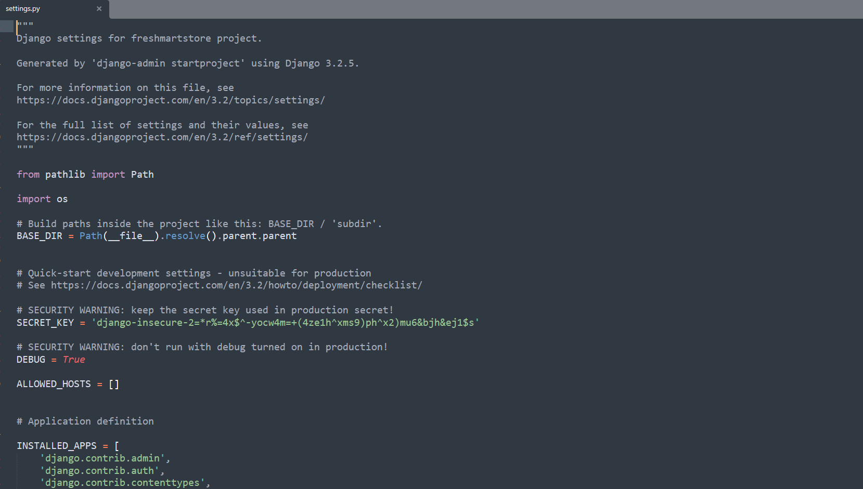**

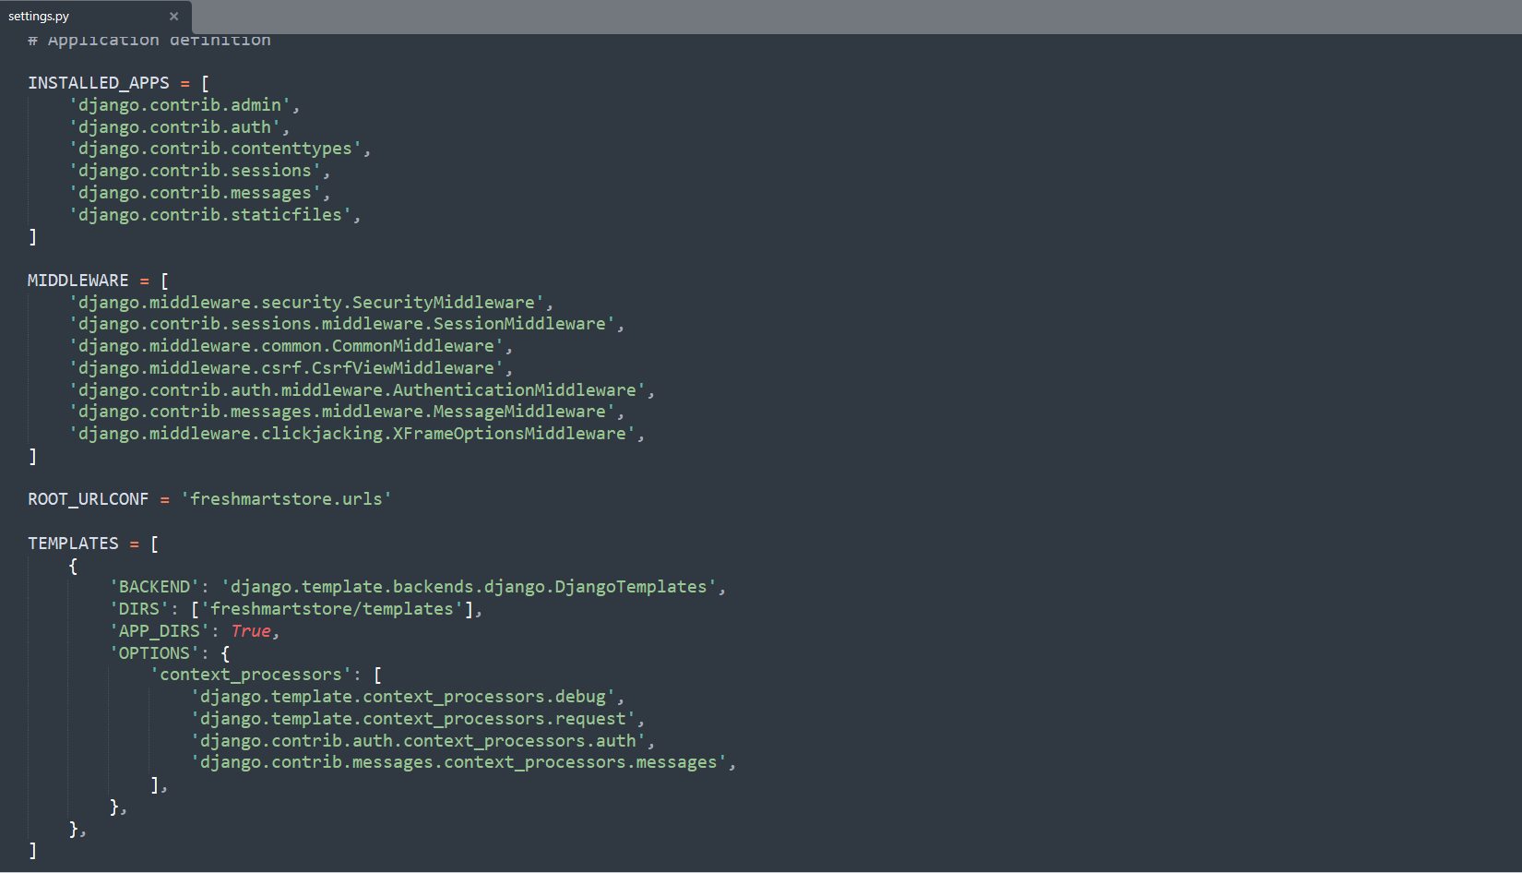Fig 4.37 Django Code

Fig 4.38 Django Code

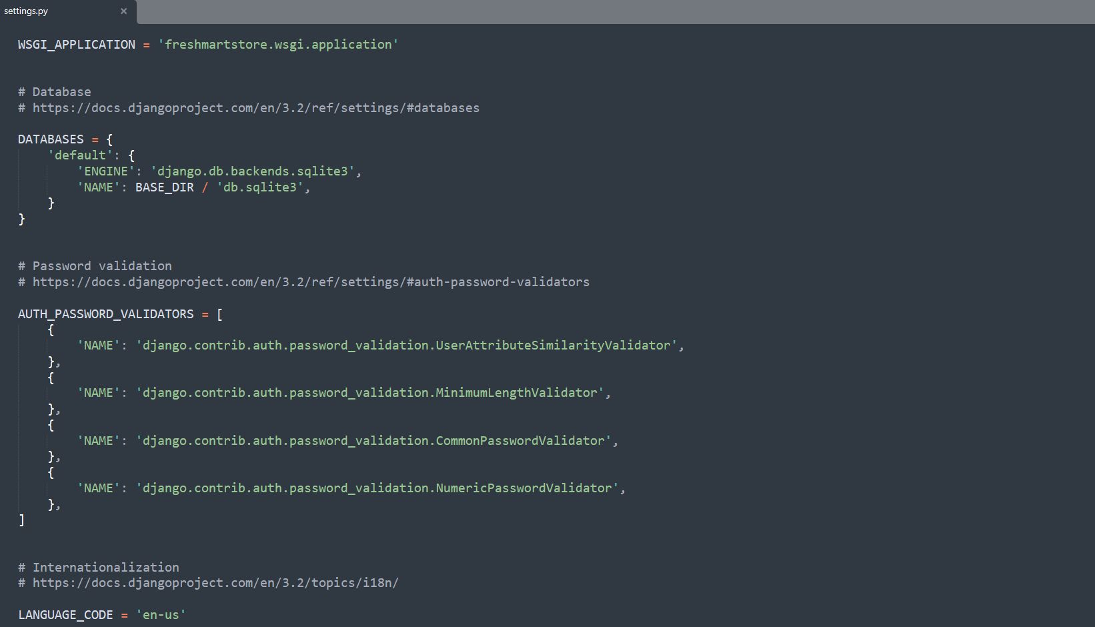

Fig 4.39 Django Code

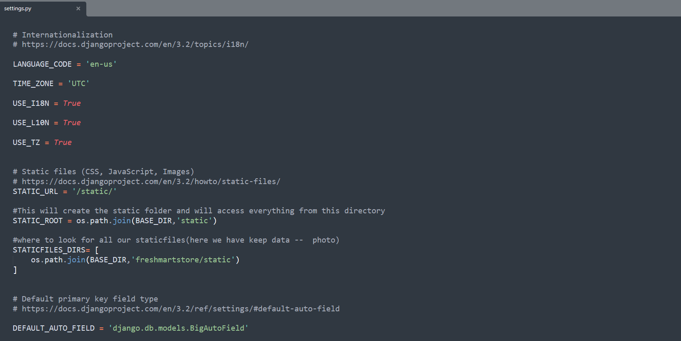

Fig 4.40 Django Code

* + 1. **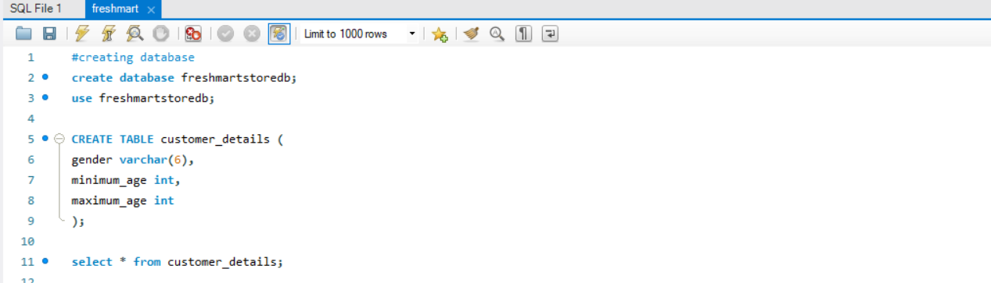SQL Script**

Fig 4.41 SQL Script Code

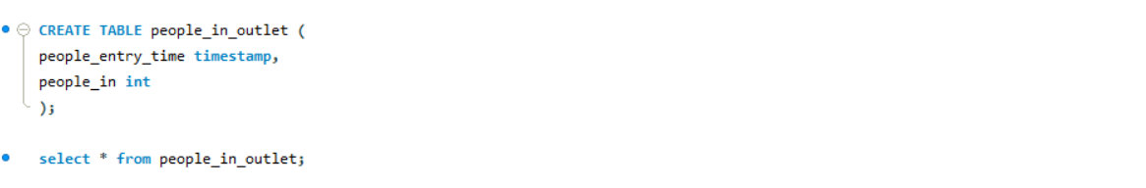

Fig 4.42 SQL Script Code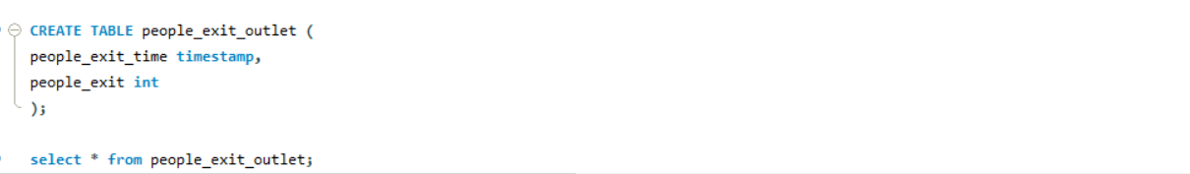

Fig 4.43 SQL Script Code

* + 1. **Requirements**

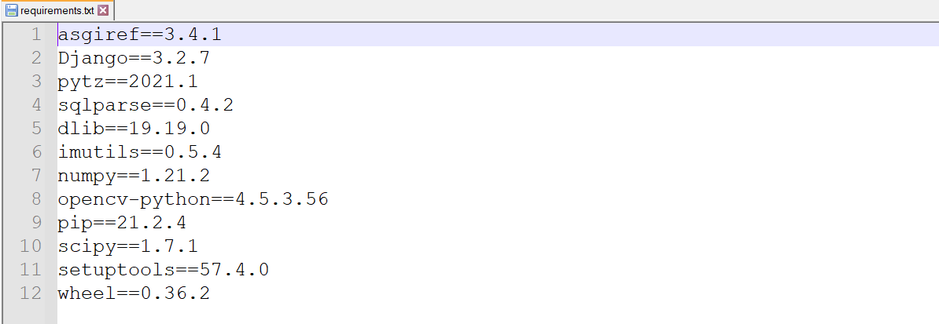

# TESTING

## TEST CASES AND REPORTS

In this project, the web application is tested by using a series of different tests whose sole purpose is to exercise the full application. It is an investigation conducted to provide stakeholders with information about the quality of the product or the services under test. It also describes the scope of testing, testing techniques to be used, resources required for testing and the schedule of intended test activities. The scope helps in identifying test items and the features to be tested. It also contains details of who will perform a given task.

Fig 5.1 shows the different test cases and their reports.

Table 5.1 Test Cases and Reports

|  |  |  |  |  |
| --- | --- | --- | --- | --- |
| **Test case id** | **Test case**  **Objective** | **Steps** | **Output** | **Status** |
| TC\_01 | Insertion of  values  in  Database | 1. Counting of people in outlet 2. People count, getting inserted into database 3. commit of database | Real Time people count getting inserted into the Database | Display of successful insertion into database on terminal |

|  |  |  |  |  |
| --- | --- | --- | --- | --- |
| TC\_02 | Insertion of Values in  Database | 1. Detecting the Age and Gender of the people entering the outlet 2. Age and gender estimation inserted into the database 3. commit of Database | Real Time Age and  gender of people getting inserted into the Database | Display of successful insertion into database on terminal |

# CONCLUSION

## DESIGN AND IMPLEMENTATION ISSUES

This work presents an approach that is very effective in displaying the real-time crowd count on the website. This information is beneficial to the customers who are visiting the trading outlets to save their time and avoid overcrowding places. The Python libraries , Algorithms and Pre-trained Caffe Deep learning models for Object Detection, Object Tracking (people), Age & Gender estimation were effective in tracing the people by processing the real-time video feed taken through a camera from the entry and exit points of the outlets. The proposed system performs admirably in situations where manual counting is simply not possible and the outlets have to manage the crowd amidst the pandemic. The project has a large future scope and is expandable in terms of scale. It can be developed to track or research crowd movement, which might be useful in managing many different social outlets, restaurants etc.

## ADVANTAGES AND LIMITATIONS

The following are the advantages of the proposed system:

* + - The proposed system is featured with a website to display the crowd count of the people.
    - This system will benefit the customers to make informed decisions about visiting the store if it is overcrowded, as they can schedule their visits accordingly to avoid the crowd.
    - This system will also benefit trading outlets to manage their crowd and further analyze the crowd by the age & gender of the customers.

The limitations are as follows:

* + - The limitations of the existing system are the crowd count tracked by the cameras in these retail stores, benefitting only trading outlets to manage their crowd.
    - This crowd count information is not helping the public in any sense.
    - The outlets do not provide a system where real-time information is displayed on the website or web application.

# FUTURE WORK

In future, we would like to upgrade our project using Cloud Services

There are many cloud services available for Object Detection and Video Intelligence in AWS and GCP.

We would like to integrate them in our project and use their functions in a more optimized manner and thus making our project more scalable and efficient.

# REFERENCES

|  |  |
| --- | --- |
| [1] | N. Pouw, Caspar AS, et al. "Monitoring physical distancing for crowd  management: Real-time trajectory and group analysis." *PloS one* 15.10 (2020): e0240963.. |
| [2] | Conte, Donatello, et al. "A method for counting moving people in video  surveillance videos." *EURASIP Journal on Advances in Signal Processing* 2010 (2010): 1-10. |
| [3] | J. Sreenu, G., and MA Saleem Durai. "Intelligent video surveillance: a review through deep learning techniques for crowd analysis." *Journal of Big*  *Data* 6.1 (2019): 1-27. |
| [4] | S. Singh, Dushyant Kumar, et al. "Human crowd detection for city wide  surveillance." *Procedia Computer Science* 171 (2020): 350-359. |

[5] Polanco, Liliana Duran, and Mario Siller. "Crowd managementCOVID-

19." *Annual Reviews in Control* (2021).

[6] Bhangale, Ujwala, et al. "Near Real-time Crowd Counting using Deep

Learning Approach." Procedia Computer Science 171 (2020): 770-779.

[7] Raghavachari, Chakravartula, et al. "A comparative study of vision

based human detection techniques in people counting applications."

*Procedia Computer Science* 58 (2015): 461-469.

[8] Liu, Zhi, et al. "Crowd counting method based on convolutional neural

network with global density feature." *IEEE Access* 7 (2019): 88789-

88798.

[9] Schlögl, Thomas, et al. *Evaluation of people counting systems*. na, 2001.

[10] Cahyadi, Nanang, and Budi Rahardjo. "Literature Review of People

Counting." *2021 International Conference on Artificial Intelligence and*

*Mechatronics Systems (AIMS)*. IEEE, 2021.

[11] Myint, Ei Phyu, and Myint Myint Sein. "People Detecting and Counting

System." 2021 IEEE 3rd Global Conference on Life Sciences and

Technologies (LifeTech). IEEE, 2021.

[12] Khan, Javed Ali, et al. "Crowd intelligence in requirements engineering:

Current status and future directions." *International working conference*

*On requirements engineering: Foundation for software quality*. Springer,

Cham,2019

[13] Boukerche, Azzedine, and Rodolfo WL Coutinho. "Crowd management:

The overlooked component of smart transportation systems." *IEEE*

*Communications Magazine* 57.4 (2019): 48-53.

[14] Bendali-Braham, Mounir, et al. "Recent trends in crowd analysis: A

review." *Machine Learning with Applications* (2021): 100023.

[15] Stojmenovic, Milos, et al. "Health Informatics: Applications of Mobile

and Wireless Technologies." (2019